Micropay® Users Manual



ComputerSearch Corporation
331 John James Audubon Parkway
Amherst, New York 14228

Phone 716-689-0511
N. F. 716-692-1409
Fax 716-689-1532
Contents
Micropay Basics 1
Starting Micropay 1
Client List Box 2
Database Functions 3
Importing Data 4
User Management 6
Creating a New User 6
Deleting a User 7
Changing a User’s Security Level 7
Changing a User’s Password 8
Preference Screen 9
New Employees Tab 9
Time Sheet Tab 10
Tool Bar Tab 11
Special Files Location Tab 12
Code Tables 13
State Codes 14
Bank Codes 15
City Codes 16
View Menu Options 17
Employee Information Screen 18
General Information 19
Monetary 21
Banking 24
Direct Deposit 24
How to Setup Direct Deposit 24
Monetary Screen after payroll runs 25
Holding a bank for one payroll 25
Holding a bank with a deduction as the money source 26
Deleting a Direct Deposit 26
Deductions 27
Deduction Type 27
Deduction Week 28
Deduction Amount 28
Stopping Deduction 28
Deduction Balance 28
Quarter To Date / Year To Date 28
Earnings 29
Accruals 30
Personnel 32
Human Resources (HR) 34
HR2 36
Adding a New Employee 37
Changing an Employee 37
Cancel Employee 39
Time Sheet Area 40
Time Sheet Header 40
Time Sheet Header Fields: 41
HR Date Alarm List: 41
Time Sheet 42
Using the Time Sheet Screen 43
Selecting an Employee 43
Deduction Overrides 44
Deduction numbers for various taxes: 44
Time Sheet Fields 45
Deleting Entries 47
Keystroke and Button Shortcuts for the Time Sheet 47
Keystroke Shortcuts: 47
Button Shortcuts: 48
Quick Pay 48
Hints & Tips 50
Preissued Checks 55
Regular Preissues 56
Third Party Sick Pay Preissues 57
Reports 58
Reports included with Micropay: 58
Reports Toolbar Buttons: 60
Export to a File 61
Export to an Email 62
Time Sheet Control Totals 63
Setup Control Totals 63
Hours & Pay 64
Deductions & Taxes 65
Validate Payroll Entries 66
Preview Payroll Journal 67
Transmit the Payroll 67
Confirmation Numbers 69
Receive Files 70
Micropay Communications 71
Appendix A – State Codes List i
Appendix B - Employee Number Box ii
Time Sheet Screen ii
Employee Information Screen ii
How to Use ii
Selecting Terminated Employees ii

Micropay Basics

Starting Micropay

Type in your User ID. Move to the Password box: use the Enter or Tab keys or click in the Password box. Type in your password. Click the “OK” button to continue or click the “Cancel” button to leave Micropay.

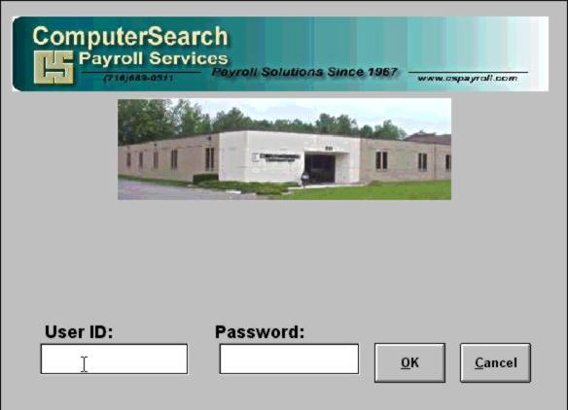

Client List Box

The Client List box will appear. Displayed in the Client List box will be your client number(s) and name(s). For most customers only one client will appear in this list. Click the “OK” button to enter Micropay. Customers who have multiple clients must select the client they wish to enter payroll data for. Click on the client to highlight and select it. Note: By default, the first client in the list is highlighted. Once the selection has been made, click the “OK” button to enter Micropay.

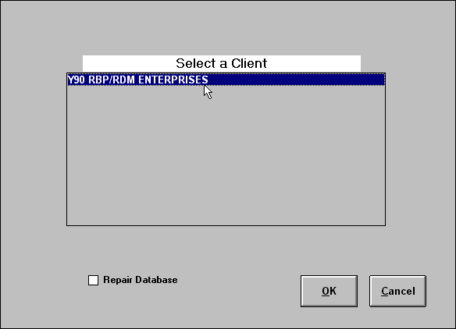

Database Functions

The Fix Database function will reorganize and compact the Micropay database. This can be done occasionally to help database access speed or if the database should become corrupt. To use the Fix Database feature, select it from the File menu. This process may take several minutes depending on the size of your database.

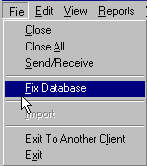

Importing Data

The Import feature can retrieve your payroll data from an outside source. This could be a time clock, spreadsheet, or another type of software. To use the Import feature, it must first be configured with ComputerSearch. The vendor of the software program from which the data will be imported from may need to be contacted as well.

Once the Import feature has been activated for your payroll, the import-file location will need to be set. This is done on the Setup tab of the Import screen. To access the Setup tab, go to the File menu and select Import. Then click the Setup tab. Set the location of the import-file in the Location box under “Import File Location.” Set the location by entering the path in the Location box or click the “Browse” button to find the file on your system. Once the location of the import-file has been set, click the “Save Setting” button.

The contents of the import-file may be viewed by clicking the “View with Notepad” button. This will bring up the file in Notepad. Changes to the data may be made and saved here. Note: If changes to the data are made here, they will not be made to the original file from which the data came. Therefore, discrepancies will exist when comparing the imported file to that of the original file.

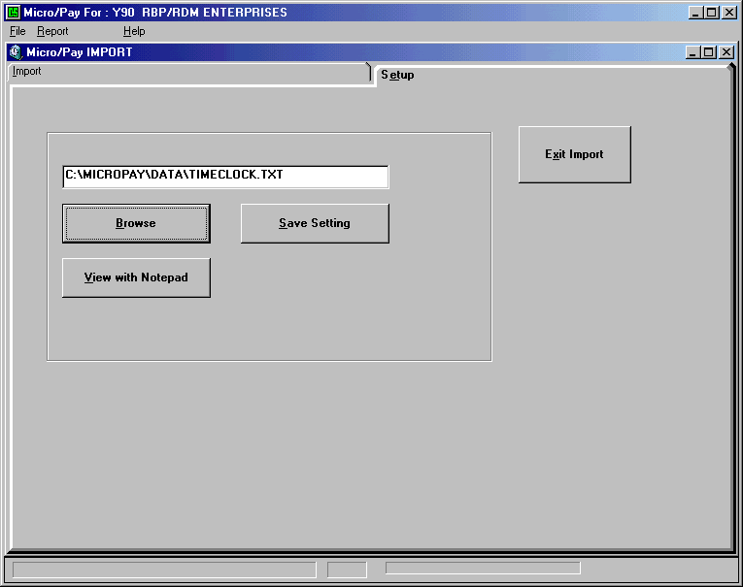

To begin the Import process, go to the Import screen. The file to be imported will be displayed in the Location box beneath “Importing.” If the file exists, the creation date and time of that file are displayed beneath it. If the filename specified does not exist, the error message "File NOT FOUND!" will appear.

To start the Import, first click the “Translate Import File” button. This formats your data in a way that Micropay can read. Once the translation has finished, you are asked to view the import file. This will allow you to compare the imported file’s information to your records and determine whether the translation was successful, i.e., has the correct information. Next, click the “Apply Transactions to Payroll” button and the data will be imported into Micropay.

If you decide that you do not want to apply these transactions to the payroll, they may be removed. If no changes have been made to the payroll data, clicking the “Remove Transactions From Payroll” button will take out all the imported transactions. If changes were made to any transaction in Micropay after it was imported, those transactions will not be removed.

A report is available on the import screen toolbar, to display exactly what was imported to the payroll system. This report looks similar to the Micropay time sheet reports, but shows only the imported data.

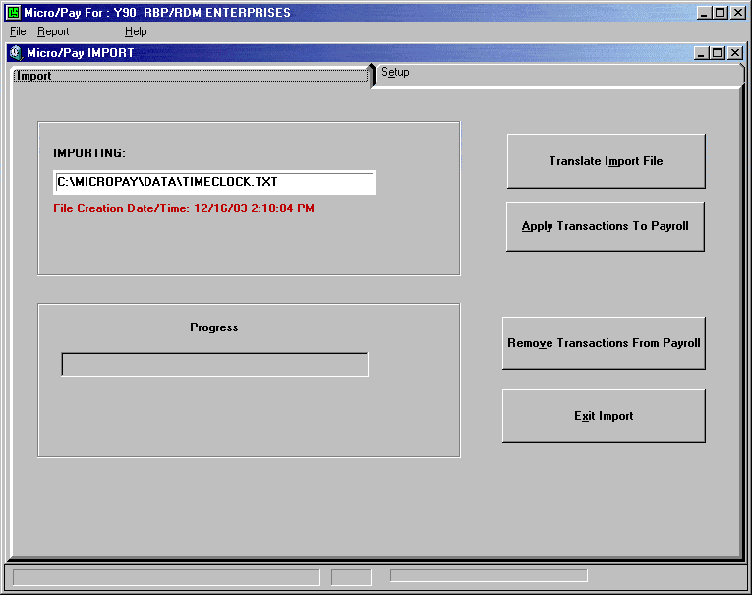

User Management

User management is accessed through the Edit menu. With user management multiple people can be setup to use Micropay each with their own user name and password. This gives each user access to only the information and functions you allow them. By assigning different security levels, users will be restricted to certain information and functions. Only users with a security level of 1, 2, or 3 may do any of the User Management functions.

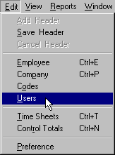

Creating a New User

To create a new user, click New User on the menu bar. Enter the User Id in the name field and then assign the user a Security Level and password. Then click the “Save Changes” button.

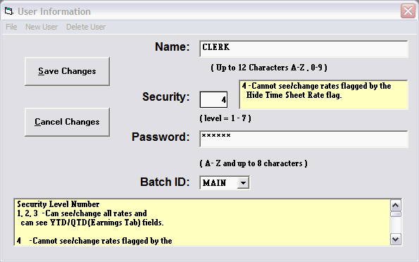

Please note that the User ID field may contain up to 12 alphabetic characters, while the password field is limited to 8 characters.

Deleting a User

To delete a user, select the User you wish to delete. From the menu bar click Delete User. A message will display asking to delete that user? Click the “Yes” button.

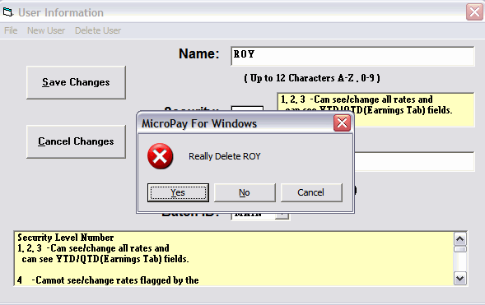

Changing a User’s Security Level

To change a user’s security level, go to the Edit menu and then select the Users option. The User Information screen will be displayed with the list of users. Click on the user whose security level is to be changed. Click in the Security Level box and then type the user’s new security level. Then click the “Save Changes” button.

The available security levels are:

1, 2, 3 - Able to see/change all rates and able to see YTD/QTD (Earnings Tab on the Employee screen) fields.

4 - Not able to see/change rates flagged by the Hide Time Sheet Rate flag (The General tab on the Employee Screen).

5 - Able to see all rates, but not able to change any rates.

6 - Able to see/changes Hourly Rates, but not able to see/change Salaried Rates.

7 - Not able to see/change any rates.

Only users of security levels 1, 2, 3 can:

-Turn off the Hide Time Sheet Rate flag (The General tab on the Employee Screen).
-See the YTD/QTD earnings fields (The Earnings tab on the Employee screen).
-Perform any User Management functions.

Changing a User’s Password

To change a user’s password, select the user. Replace the current password with the new password and click the save button that will appear once you start erasing the old password or have selected a user.

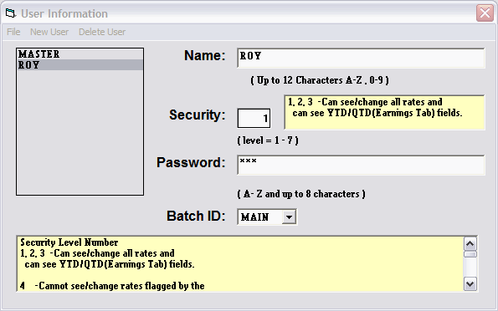

Please note that the User ID field may contain up to 12 alphabetic characters, while the password field is limited to 8 characters.

.

Preference Screen

The Preference screen is where certain defaults are set for Micropay. There are four areas available to customize: New Employees, Time Sheet, Tool Bar, and Special Files Location. The Preference screen is accessed through the Edit menu; click the Edit menu and then select the Preference option.

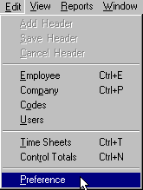

New Employees Tab

There are five options that are set on the New Employees tab: Sex, State, Rate, Department and Hire Date. Remember: Click the “Save” button, to the right, when you are finished making changes. If a mistake is made, click the “Undo Changes” button immediately, this will restore the previous settings (Note: Once changes are saved, “Undo Changes” will not restore the previous settings).

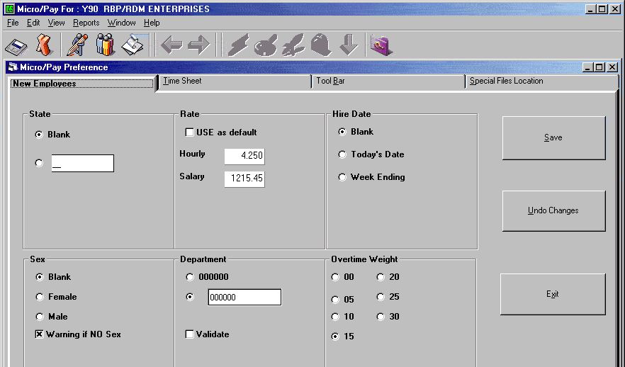

Sex - May be set to blank or have a default sex selected, Male (M) or Female (F). Note: Micropay will warn when an employee does not have a sex entered. This warning may be turned off here.

State - A default state may be entered, e.g., NY. All new employees will automatically be coded for that state. This field may be left blank and the state can be entered when setting up new employees.

Rate - A default rate for new employees may be entered. If most of your employees start at a particular rate, that rate may be entered here and set as the default. Having a default for both hourly and salaried employees is possible. When a new employee is entered, the hourly rate field will be filled with the default rate entered here (see the Monetary tab from the Employee Information Screen). If the new employee is salaried, clear the hourly field (click in the hourly field and press the F2 key), then the salaried field will be filled with the default rate for salaried employees.

Department - A default department number maybe entered. You can choose between the ”000000“ option or set a department number (maximum of 6 digits) as the default for new employees. Validate will check the Department table each time a department number is entered and will display an error if the department has not been setup.

Hire Date - A hire date may be automatically entered for new employees. Today’s Date or the Week Ending date of the payroll may be used. If you do not wish to have this field automatically filled, select Blank and nothing will be entered.

Time Sheet Tab

From this screen the Job Number and Employee Check Digit fields on the Time Sheet can be turned on or off. These fields are both turned off by default. Click in the box next to the desired field in order to have it displayed and available on the Time Sheet screen. If the Time Sheet screen is open, close the screen and then reopen it. The selected field(s) will now be available for use.

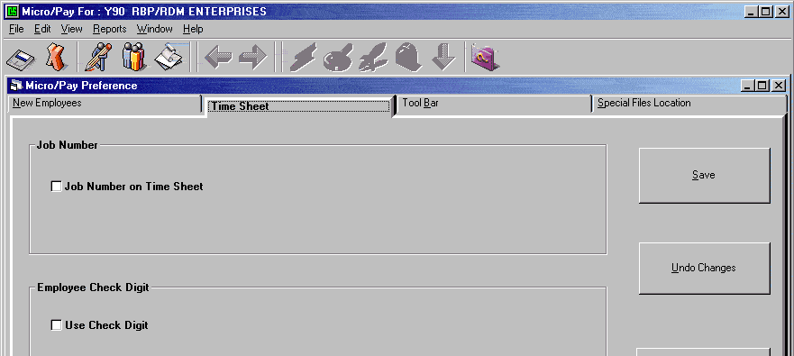

Tool Bar Tab

The hours entered by the “Regular” and “Holiday” buttons on the Tool Bar used by the Time Sheet screen can be customized. For the “Regular” button you may enter the number of hours to be given to Hourly or Salaried employees and the entry code to be used. For the “Holiday” button, the entries are the same for both hourly and salary, i.e., the “Holiday” button will enter hours, on the Time Sheet, for Hourly and Salaried employees. The Temp Rate (see the Time Sheet screen) is zeroed out for the Salaried employees. To make changes, click in the Entry Code and Hours boxes and type the desired values. The keyboard shortcut for the “Regular” button is the F5 key and for the “Holiday” button is the F8 key.

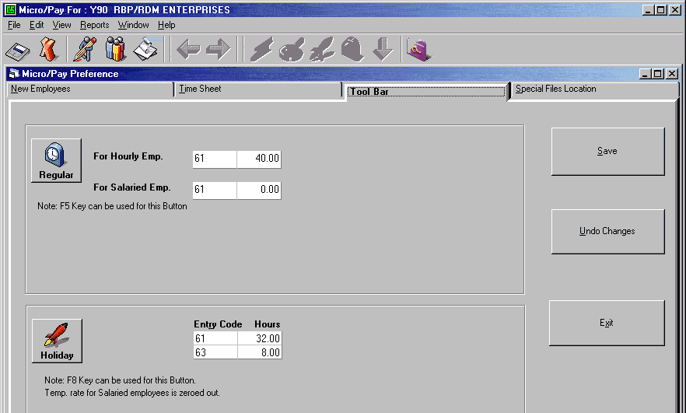

Special Files Location Tab

If Special Files are to be downloaded from ComputerSearch, a destination for those files will need to be specified.

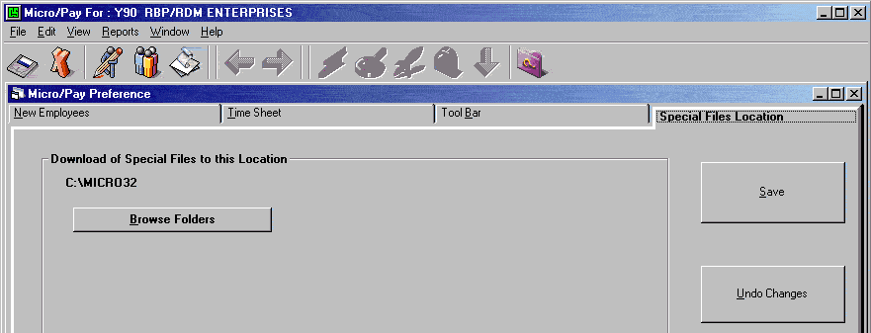

Clicking the “Browse Folders” button will bring up the Drive and Directory boxes. Select the drive and directory where these files are to be placed.

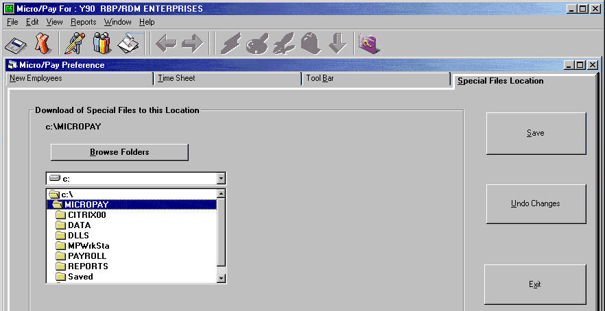

Once the location has been selected, click “Save” and the new path will be displayed above the "Browse directories" button.

Code Tables

Code tables are accessed through the Edit menu; go to the Edit menu and select the Codes option.

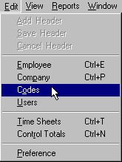

This will bring up the Code Defaults screen. Here the State, Bank or City Code tables can be selected.

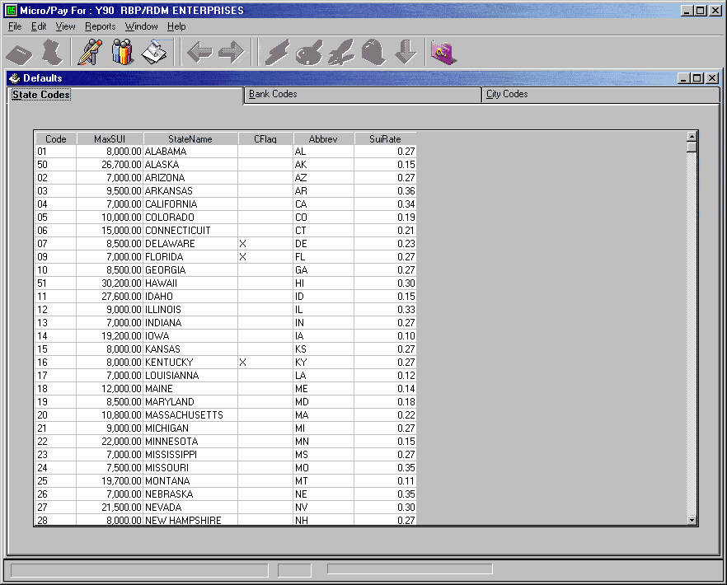

State Codes

All employees must have a State Code. Use the State Code in which the employee is working. To view the State Codes go to the Edit menu, then select the Codes options and pick the State Code tab. The State Codes screen shows: the code number for the State, the State’s current “State Unemployment Income” (SUI) maximum, the State’s name, Cflag, State abbreviation, and the current default SUI rates. Valid codes are from 1 to 52 with New York being 31. See Appendix A for a complete listing of State Codes.

Note: All states require an application for State Income tax, State Unemployment tax and occasionally local tax, to be filed. If your company has employees working in another state, you must file an application in that state.

Bank Codes

Bank Codes are used for setting up direct deposit for an employee. The Bank code tells ComputerSearch which bank to transfer the employee’s money to. To change the order in which the Bank Codes are displayed pick: Code, Description, or Routing Number. The Bank Code is the two character code from this table, which was entered in the Bank Code field on the Monetary Screen (see Monetary section). Description contains the name of the Bank and Routing Number is the Bank’s transit routing number. Contact ComputerSearch for a current listing of Bank Codes.

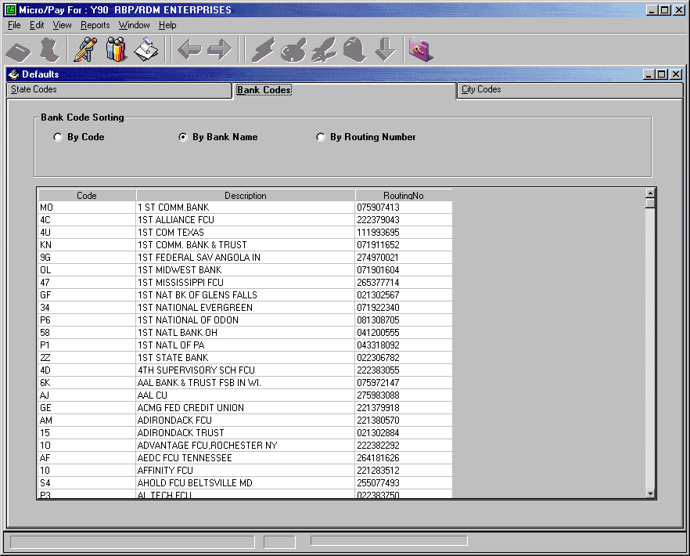

City Codes

The City Codes’ table displays the following information about the City: State Code, City Code, City Name, STS State (Code), STS City (Code) and City Percent. STS stands for the Tax Filing service ComputerSearch uses; currently it is Ceridian Tax Service. City Percent is the rate at which the City taxes an employee’s Gross Pay.

City Codes are used to deduct city taxes from an employee. City taxes will only work if ComputerSearch has a deduction set up for it. If a city tax is needed that is not currently in the table, call ComputerSearch Customer Service.

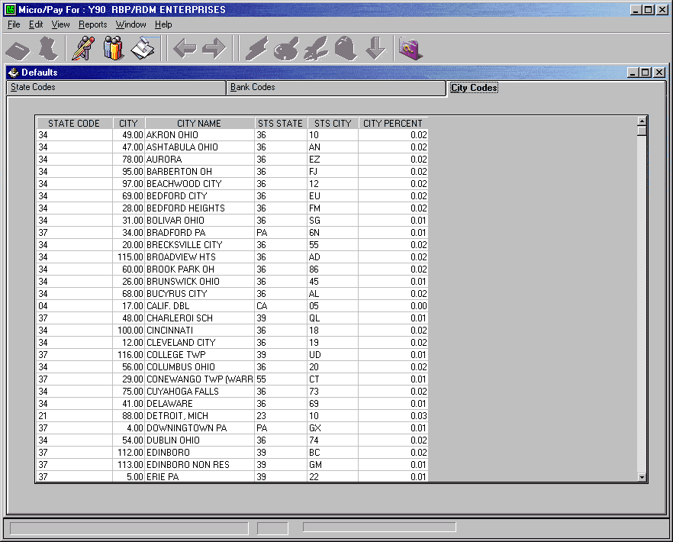

View Menu Options

The View Menu Options controls which employees are displayed and in what order on the Time Sheet and Employee screens. Default settings are controlled by your client setup with ComputerSearch. Contact ComputerSearch customer service if you wish your view defaults to be changed.

The first option under the View menu is Group by. Displayed employees may be grouped together by Department Number, Division or, Both. If None is selected, the Sort by option determines the order in which employees are displayed.

The next option is Sort By. After determining how your employees should be grouped, Sort By will put them into the desired order. Employees may be sorted by their Name or their Employee Number. Also, Sort By offers an option to sort by Name ONLY or Employee Number ONLY; selecting one of these options will automatically turn Group By to None.

Select determines which employees are displayed. In the top part of Select you may choose from either Active, Terminated or, Both. In the bottom part of Select, employees can be selected by their pay type: Salaried, Hourly, or Both. If Both is chosen as the selection criteria from both parts of the select menu (top and bottom), all employees will be displayed. Using the select option, it would be possible, for example, to display only the Terminated Hourly employees to ease looking for an employee to reinstate. Select also determines the employees to receive pay when using the Quick Pay feature.

Auto Refresh will automatically update displays based on the new selection criteria and/or changes made to employee information. To control when refresh occurs, turn off Auto Refresh. Select the Refresh option when you want to have the display updated.

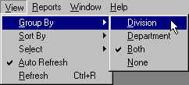

Earnings

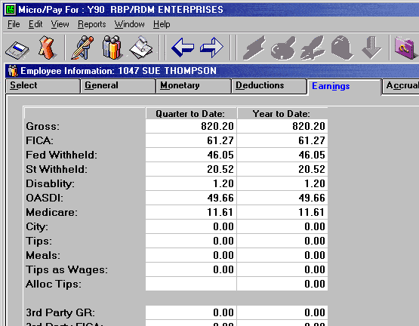

The Earnings screen displays the Quarter-To-Date (QTD) and Year-To-Date (YTD) pay information for the selected employee. This information includes: Gross, FICA, Federal Withheld, State Withheld, Disability, OASDI (Social Security), Medicare, City, Tips, Meals, Tips Over Minimum (Tips Over Min), Allocated Tips (Alloc Tips), 3rd Party Sick Pay Gross (3rd Party GR), 3rd Party Sick Pay FICA (3rd Party FICA), 3rd Party Sick Pay Nontaxable Gross (3rd Party NonTx GR), 3rd Party Sick Pay Federal Withheld (3rd Fed Withheld, 3rd Party Sick Pay State Withheld (3rd State Withheld), Month-To-Date Gross (MTD Gross), Tax Shelter Annuity (TSA), Federal Unemployment Tax (FUTA), State Unemployment Insurance (SUI) and FICA Taxable (FICA Txbl).

To access the Earnings screen click the Employee Information button on the toolbar or go to the Edit menu, select the Employee option (Ctrl + E), and then click on the Earnings tab. Note: The information displayed on this screen is not editable.

Accruals

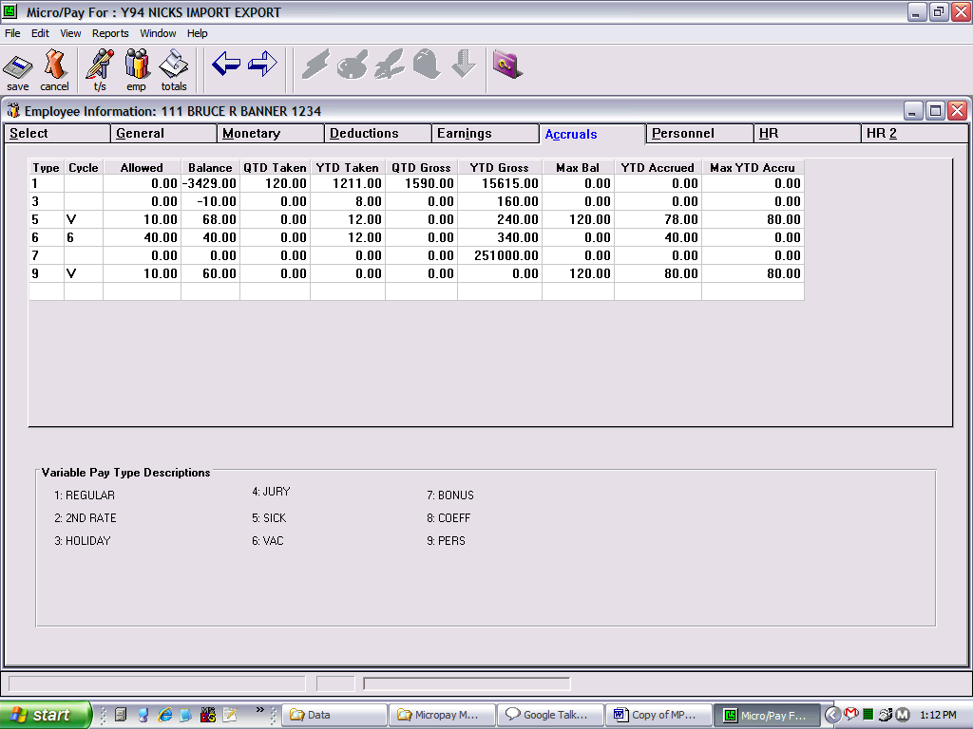

The following employee information can be viewed on the Accruals screen: Pay Type, Balance Hours, YTD and QTD Taken Hours, YTD and QTD Gross, and if used, the codes for accumulating these hours. To access the Accruals screen click the Employee Information button on the toolbar or go to the Edit menu, select the Employee option (Ctrl + E) and then click the Accruals tab.

Pay Type - A description of your Pay type is displayed at the bottom of the screen. Pay type, may be Regular, Vacation, Sick, etc.

Cycle Code - Cycle codes determine how often an employee receives his/her allowed hours for a Pay type. The codes:

1, 2, 3, 4 - Yearly at the end of this quarter
5 - Accrues annually based on HR Date 1
6 - Accrues annually based on HR Date 2
7 - Accrues annually based on HR Date 3
8 - Accrues annually based on HR Date 4
9 - Accrues annually based on HR Date 5

A - Percentage of All Regular Hours Worked - Only Entry Codes 61 & 62
M - Monthly - On the first pay of the following month for previous month accrual
( continued )
P - Percentage of Hours Worked - All Regular Hours any Entry Code
Q - Quarterly
V - Percentage of all hours (Regular and Overtime) all pay types
W - Weekly
Y - Yearly based on Hire Date
Z - Yearly based on Hire Date. Writes over balance, no carry over.
X - Yearly based on Hire Date. Writes over balance, no carry over UNLESS negative then subtracts Negative balance from new balance.

Max Bal - Maximum number of hours an employee can have in his balance. Will not accrue any additional hours until balance is below Max Balance.

YTD Accrued - Number of hours accrued this year.

Max YTD Accru - Maximum number of hours an employee can accrue in a year.

Allowed Hours - Allowed Hours are the number of hours an employee will accumulate for a specific pay type at the end of the cycle as defined by the Cycle Code. This may also be the percentage of hours to accumulate for a pay type.

Balance - Remaining hours for that pay type. The balance is setup by the client for their employees. The amount shown reflects a declining balance.

QTD Taken - Hours taken within that quarter for that pay type.

YTD Taken - Hours taken to date for that pay type.

QTD Gross - Dollars earned within that quarter for that pay type.

YTD Gross - Dollars earned to date for that pay type.

Personnel

The Personnel screen has fields for: personnel data, number of weeks worked, and various employee date information.

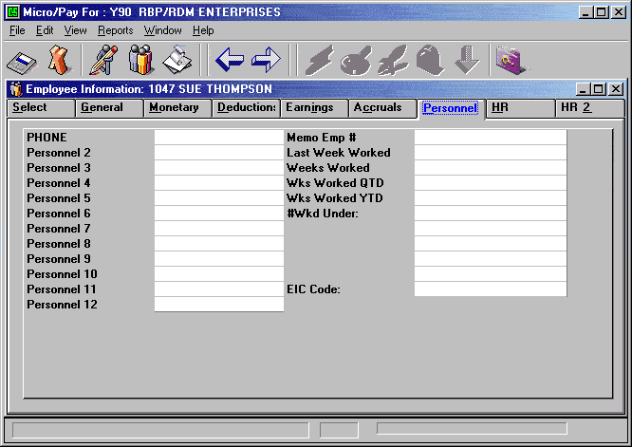

Personnel Fields - There are twelve personnel fields available in Micropay for your use. These fields may be filled with any alphanumeric data. Sizes for the personnel fields:
Fields 1-3 10 characters
Fields 4-10 4 characters
Fields 11-12 6 characters

Titles can be entered for Personnel fields. Contact ComputerSearch Customer Service for more details.

Memo Employee Number - Memo Employee Number will hold seven characters that are alphanumeric. The Employee’s phone number is typically placed in this field; however, any entry may be placed here.

Weeks Worked - The number of weeks worked by this employee.

Last Week Worked - The last week number during the year this employee received pay. The week number starts at the beginning of the year with 1 and counts until the end of that year.

Weeks Worked QTD - The number of weeks this employee was paid during that quarter.

Weeks Worked YTD - Reflects the number of weeks an employee was paid during that year.

# Wkd Under - This field is obsolete, but has been retained to maintain compatibility with historical data.

EIC Code - The Earned Income Credit (EIC) code must be set up by ComputerSearch before it can be used, to do this call customer support at (716) 689-0511. This code refers to the status of employees who file for EIC on their tax returns. The valid codes which may be entered in this field are:
1 = Single or Head of Household
2 = Married, both filing for EIC.
3 = Married without spouse filing

Human Resources (HR)

The HR screen has fields for human resources related data, title, phone number, e-mail address, ID photo etc. These fields are not used in payroll processing; they are for your records only. All data entered on this page will be transmitted to ComputerSearch for storage.

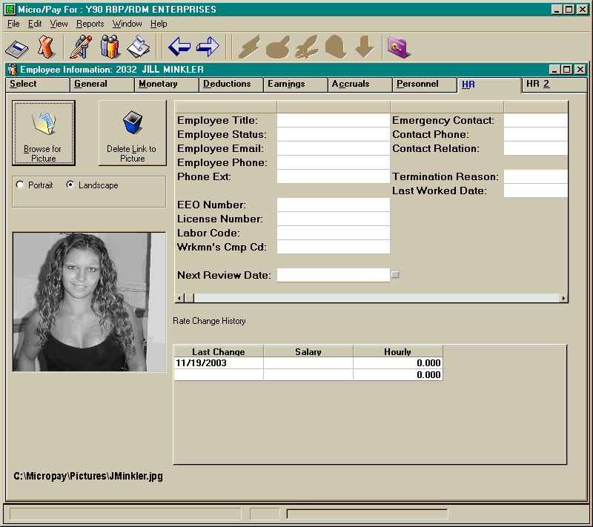

Browse for Picture - An Employee ID photo may be displayed on this page. Any JPEG (JPG) or Bitmap (BMP) file may be displayed. The Browse for picture button allows you to create a link to an existing image anywhere on you local or network disks. This feature may be used to add new images or change existing image links. Images may be displayed in either portrait or landscape orientation by selecting the appropriate radio button.

Delete Link to Picture - This feature allows you to remove an existing image file link; it does NOT delete the image file itself.

Employee Title - The title field is a text field to provide you with a means for classifying employees.

Employee Status - This is an editable, single character data field provided as an option for your records.

Employee Email - A text data field has been provided for you to record a single email address for each employee.

Employee Phone - You may record one phone number per employee in this field.

Phone Ext. - This field is useful for keeping track of in-house phone extensions. An employee directory report can be generated from this data using the CS Reports program.

Next Review Date - Performance/salary review dates may be tracked in this field. If you wish this data to appear in the date alarm section of the time sheet header page the box next to the data field must be checked for each employee. This field MUST be updated manually.

Several fields are available to record individual emergency contact information. CS Reports may be used to generate an emergency contact directory using this information.
Emergency Contact Name- This text field allows you to record the name of an individual to be contacted in case of emergency.

Contact Phone- The phone number for the emergency contact may be stored and edited in this field.

Contact Relation- It is often necessary to know the relation of an emergency contact to the employee. This information may be stored here.

Termination Reason - An editable text field is provided for recording termination information.

Last Worked Date - This date field is not automatically populated, but is provided as an option for your record keeping.

Rate Change history is a new section that is automatically populated each time a change is made to an employee's rate of pay.
Last Change - The date of each rate change is recorded in this editable field

Salary - Changes in the salaried rate of pay will cause the new salary rate to be displayed here.

Hourly - Changes in the hourly rate of pay will cause the new hourly rate to be displayed in this column.

HR2

The HR2 screen has fields for additional user defined human resources related data including COBRA insurance information. These fields are not used in payroll processing; they are for your records only. All data entered on this page will be transmitted to ComputerSearch for storage along with your payroll data.

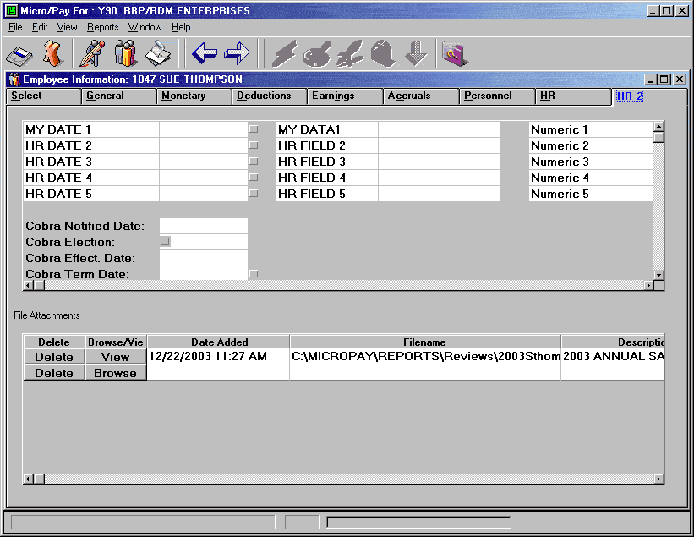

Cobra Notified Date - Enter the date of the employee is notified of COBRA eligibility; this date is NOT available in the data alarm list on the timesheet header page.

Cobra Election - Click on the check box to indicate that the employee has elected to use Cobra benefits.

Cobra Effect Date - Enter the date that COBRA benefits went into effect, this date is NOT available in the data alarm list on the timesheet header page.

Cobra Term Date - Enter the date on which the COBRA benefits will terminate. This date WILL be displayed in the data alarm list on the timesheet header page if the checkbox to the right of the field is checked.

File Attachments -
Browse/View - Any document on you local or network disks may be associated with and employee. This feature may be used to keep track of letters of commendation, reprimand, or other special recognition. Once a file has been selected the time that the file was added and the full path specification to the file are displayed in editable fields. After selecting the file, the Browse button changes to View and the Files may be viewed in the default application by clicking on the button.

Delete - This feature allows you to remove an existing file link, it does NOT delete the file itself.

Adding a New Employee

To add a new employee, click the Employee Information button, then from the Edit menu select Add Employee. The General Information screen will be displayed and the next available employee number will be generated. The Employee number may be changed to any available number from 1 to 9997; simply type the new number and that number will appear in the Employee number field. Note: Once the Employee has been saved the Employee Number cannot be changed. If an employee has been terminated, their employee number can be reused after ONE CALENDAR YEAR. For example, an employee terminated in March 1999, their number can be used again in January 2000. If an employee is terminated and then is rehired, their previous employee number may be reused, simply pay the terminated employee and they will be reactivated. Note: This must be done in the same year. Terminated employees are dropped from Micropay at the end of the year.

Now enter the rest of the information for the Employee on this screen and any others as necessary. The following is the minimum information necessary for a new employee: Name, State Code, Sort Code, Rate of Pay, Federal Exemptions, Marital Status and Department Number. This information is contained on the General or Monetary screens as follows:

General Information Screen Monetary Information Screen

Name Rate (Hourly or Salary)
State Code Federal Exemptions
Department Number Marital Status
Sort Code

Once all your information has been entered, be sure to save the changes by clicking the “Save” button or select Save Employee under the Edit menu. To abort adding a new employee, select Cancel Employee from the Edit menu. This must be done before saving or else you cannot abort adding a new employee. Note: Once an employee has been added the entry cannot be deleted.

Changing an Employee

To make a permanent change to an employee, find the field you need to change, then click in that field and type the new or correct information. Once finished save your changes by clicking the “Save” button or from the Edit menu select Save Employee. If you decide you do not wish to make these changes, go to the Edit menu and select Cancel Employee, this will undo your changes since your last save to this employee.

Terminating/Inactivating an Employee

Terminating an employee is done from the Time Sheet screen. To terminate an employee use an entry-code of 19 in the Entry field on their time sheet, then save the employee. Alternatively, using an entry code of 1I causes the employee to be marked as "inactive". Inactive employees are handled exactly the same as terminated employees in every way, except that they are NOT removed from your employee database at the end of the year. Now a small window will appear asking for a termination date. You may enter a date or accept the date already in the window, which is the week ending date for the current payroll. The terminated box on the General Information screen will now be checked and the date entered will appear in the Terminated Date on that screen as well. Note: If the Select option from the View menu is not set to either “Both” (Active and Terminated) or “Terminated,” the terminated employee will not be displayed.

To reactivate an employee, change the view to show terminated employees and then on the Time Sheet screen make an entry for that employee with any entry code other than 19 or 1I.

Cancel Employee

Cancel Employee will undo changes made to an employee since the last time they were saved. Employee information is restored to the settings before the last save. If you Cancel while adding a new employee and before saving, that employee will be aborted.

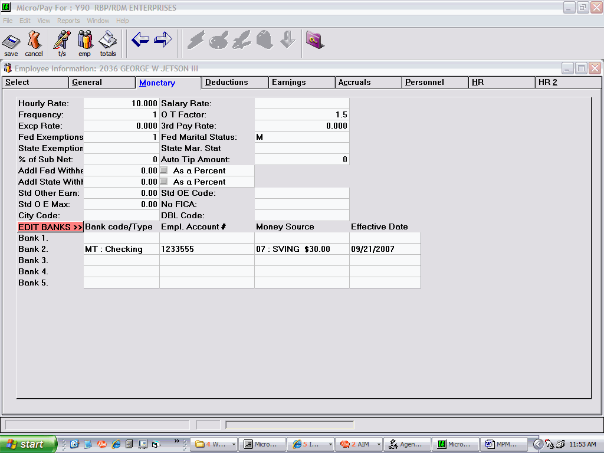

Cancel button

Time Sheet Area

The Time Sheet area contains tabs for displaying and editing data for the Time Sheet Header, individual Time Sheets, and Preissued Checks.

Time Sheet Header

The Time Sheet Header must be completed before any changes or additions can be made to the payroll. If the payroll has been transmitted, a “New” button appears on the Header screen. Click the “New” button to start a new payroll.

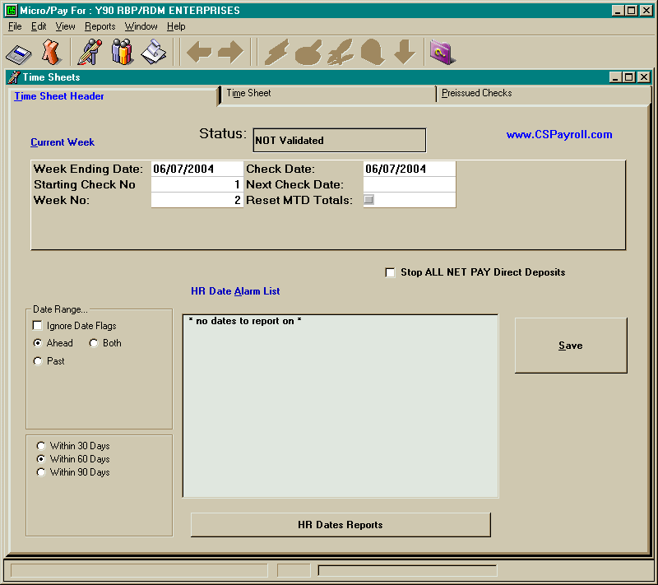

All fields at the top of this page except the Next Check Date must be filled out. Double clicking the mouse in any date field will bring up a calendar tool. Once the Time Sheet Header has been filled out, click on the “Save” button.

Time Sheet Header Fields:

The Status box will display “Not Validated.” Once the payroll information has been entered and validated, the display will change to “Validated.” After transmitting the payroll to ComputerSearch, the Status changes to “Transmitted.”

Week Ending Date - The date the pay period ends.

Check Date - The date checks are to be dated.

Starting Check Number - Enter the number for the next check or enter “1". If “1” is used, the next number in order will be used to date the check.

Next Check Date - (Optional) The Check Date of the next payroll expected to run.

Week Number - This indicates the Week of the month, based on check date, for the current payroll. Valid values are 1-5 for weekly payrolls and 1-3 for biweekly payrolls.

Reset MTD - Resets the department summary report for the month. Normally done on week 1 of the month. This field is a ”check box” and will reset MTD totals when the box is checked.

Stop ALL NET PAY Direct Deposits - this check box allows you to stop the direct deposits for this payroll.

HR Date Alarm List:

Several dates from the Employee Information HR and HR2 tabs can be used to trigger alarms shown in the display list at the bottom center of the Time Sheet Header page. To make use of this feature you must enter date values in an alarm capable date field (Review Date, Cobra Termination Date, HR Date 1 to 5) AND click on the check box next to the field for each employee. None of these date fields are automatically updated so that you may look for past dates to determine if one has been overlooked.

Date Range - There are two sections under the date range title. The top portion allows the user to select one of four options:
Ignore Date Flags - basically turns off the alarm system, all flagged dates are ignored.
Ahead - displays names of all employees with flagged dates occurring in the next 30, 60 or 90 days
Past - displays names of all employees with flagged dates having occurred in the past 30, 60 or 90 days
Both - displays names of all employees with flagged dates having occurred in both the past and the upcoming 30, 60 or 90 day
The second portion permits the user to specify how long the date alarm range should be, 30 60 or 90 days.

Any flagged dates that fall within the specified date range will cause a title (i.e. Review Date) to appear in the display list. The title line is followed by the names of all employees having, in this case, a review date with in the specified date range.

Time Sheet

The Time Sheet screen is where most pay entries will be made for employees. In the lower right corner of the screen is an information box. This box displays important pay information for the selected employee; the information in the box cannot be edited. Also on the Time Sheet is the Quick Pay button. Quick Pay is an easy way to pay all hourly or salaried employees (see Quick Pay section for more details). Common functions are available from the Tool Bar on the Time Sheet screen (see Keystrokes and Buttons section for more details). In the View Timesheet Entries section you can select between viewing One Employee or All Employees. The All Employee view mode allows you to browse through all of your payroll entries, but data cannot be entered in this mode. The One Employee view mode must be used to enter payroll data.

Using the Time Sheet Screen

This is a general explanation of how to create a pay entry.

Selecting an Employee

First, select the employee for whom an entry will be made. To do this: move the highlight bar to the desired employee and press Enter or place the mouse pointer over the desired employee and double click the left, mouse button. Once an employee has been selected the cursor will move to the entry code box and the name of the employee will appear in the title bar.

Type the Entry Code and press Return. Fill the other fields as necessary. To pay a salaried employee their standard salary only the entry code is needed.

If additional lines are needed for an employee, press the Down Arrow or Enter at the end of the line (column labeled OT). To access the Deduction area, click in the Deduction number box or press Alt-D. Enter the Deduction number, the amount and the Entry Code for the deduction. Note: By clicking in the Deduction number box, then clicking the right, mouse button, the Client Deductions window will be displayed. Double clicking on an entry in the Client Deductions window will cause that deduction code to be entered with the pay code from the first timesheet line for this employee.

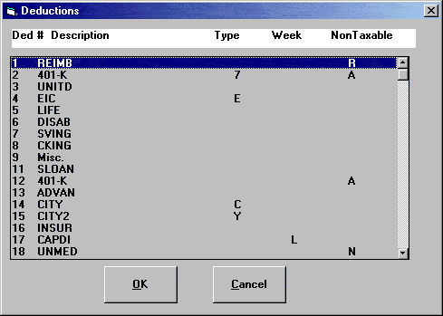

Deduction Overrides

To enter the Deductions area on the Time Sheet screen, click in the Deduction number box or press Alt-D. Enter the number for the deduction to override. Pressing F4 or clicking the right mouse button will bring up the Client Deductions window that has a list of your deductions. If a specific amount is needed, type it in the Amount box, then press Return. The cursor will now be in the Entry box. Here the Entry Code is entered for the deduction. If an employee has more than one check, this tells the computer from which check to take the deduction.

The last box is the Force/Omit box. To stop a regular deduction from a particular check, select Omit here by clicking the down arrow and choose Omit from the list. If a standard deduction is to be deducted from a check that it would normally not (such as an 81 check), select Force here. When using Force/Omit an amount need not be entered.

To omit all deductions (except taxes) on a check use deduction number 99 and the Force/Omit box will show Omit All. This will stop all voluntary deductions.

Deduction numbers for various taxes:

55 - Social Security - Never change or else it may create an “Out of Balance” with your “941" on your quarterly reports. Call ComputerSearch for more information.
56 - Medicare
52 - Federal Tax
53 - State Tax
54 - Disability

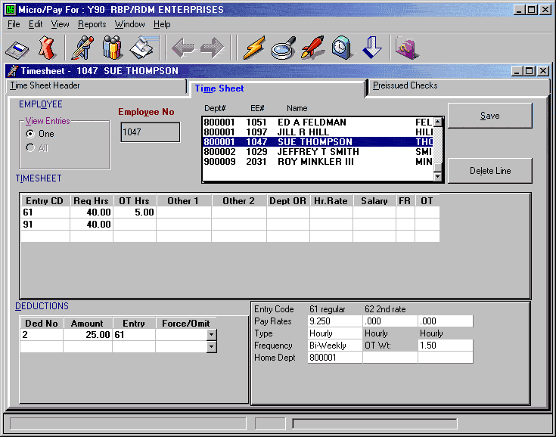

Time Sheet Fields

Entry Codes (Entry):

61 - Regular Pay
62 - Second Rate
63 - Holiday Pay
64 - Jury Pay
65 - Sick Pay
66 - Vacation Pay
67, 68, 69 - Defined by the Client

All Sixty series entry codes combine onto one check. Alpha entry codes act the same as the Sixty series, each letter representing a separate check, i.e., A1=61, A5=65, B1=61, etc.

7X - Single line Regular Check
Seventy series’ checks do not combine as a single check. 71 and 72 checks are two separate checks; both at the employee’s regular rate of pay, and will take all scheduled deductions.

8X - Bonus Check
Eighty series’ checks only take dollar amounts from the Other-1 and Other-2 fields. Taxes are the only deductions taken unless a deduction is forced or a deduction override is entered.

9X - Separate Vacation Check
Ninety series’ checks are each for a separate check for vacation with X being the week of the month for which the check is being issued. If deductions are setup to come out on a specific week, a vacation check with that week (as the second digit) will have that deduction.

Regular Hours (Reg Hrs): All hours entered here will be taken at straight time, multiplied by the First (61) or Second (62) rate depending on the Entry Code. Note: If a Temporary Rate is entered, this will override the Employee’s normal rate. Hours entered for a salaried employee are for recording purposes only; they will not affect the salary. Maximum value for a Regular Hours entry is 999.99.

Overtime Hours (OT Hrs): All hours entered here will be calculated at the Overtime Factor. For a salaried employee if he/she has an exception rate this times the Overtime Factor will be used for this calculation. Maximum value for an Overtime Hour entry is 999.99.

Other 1 - Entries here will be added to the gross as dollar amounts. The Eighty series’ checks only look here for a dollar amount to figure the gross. The maximum dollar amount for an Other-1 entry is $999,999.99.

Other 2 - Entries here are also added to the gross as dollar amounts. For restaurant payrolls, the dollar value of tax-exempt meals is entered here. The maximum dollar amount for an Other-2 entry is $999,999.99.

Department Override (Dept OR): This field is used to assign part of an employee’s earnings to a department other than his/her home department. Enter the desired department number for the override.

Temporary Rate (Hr. Rate or Salary fields): Use these fields to pay an employee a different rate instead of the normal rate. Enter the amount in the appropriate field, e.g., for an hourly employee, place the amount in the Hourly Rate (Hr. Rate) field or for a salary employee, place the amount in the Salary Rate (Salary) field. The Hourly Rate field has a three decimal place limit and a maximum value of 9,999.999. The Salary Rate field has a two decimal place limit and a maximum value of 99,999.99. Note: DO NOT enter dollar signs in these fields.

FR - A temporary override of the frequency code for that check only. This will change the tax calculations to the following:

1 - Weekly
2 - Bi-Weekly
3 - Semi Monthly
4 - Monthly
9 - Maximum Federal and State tax rates

Overtime (OT) - A temporary override of the Overtime Factor just for that check. The codes are:

00 - Non-Paid Time
05 - Half Time
10 - Straight Time
15 - Time and a Half
20 - Double Time
25 - Double Time and a Half

Job Number (Job No): Job number for this pay line. This information is used on the optional Payroll Job Distribution report. Contact ComputerSearch for information on setting up this report. Note: This feature is disabled by default (see the Time Sheet Tab section to enable this feature). Any numeric values may be used for the Job Number. Note: if the Job Number is to be used to track commercial work, such as construction jobs, place the letter “c” in front of the job number. For further information contact ComputerSearch.

Deleting Entries

Entries may be deleted, on the Time Sheet screen, one line at a time or all entries at once, for an employee. The “Delete” button found on the screen will delete the current line. The Delete Time Sheet command under the Edit menu will delete all entries, i.e., multiple lines, for an employee.

Keystroke and Button Shortcuts for the Time Sheet

There are some special keystrokes and buttons designed to make the Time Sheet screen easier to use.

Keystroke Shortcuts:

Tab or Enter keys - After entering a value in the Entry Code field, pressing the Enter or Tab key will advance the cursor to the next field and generate a new line.

Arrow Keys - The Up/Down arrow keys will move the cursor between lines. The Left/Right arrow keys will move the cursor within a field.

/ - Pressing the slash key will save the current employee’s data and move the highlight bar to the next employee in the list box.

Alt-D - Moves the cursor to the Deductions area at the lower left of the screen; it places the cursor in the Deduction Number box.

F2 - Clear a field.
F4 or Right Mouse Button - Brings up a pop-up menu of choices where available.
F5 - On time sheet is the same as pushing the regular hours button.
F8 - On time sheet is the same as pushing the holiday hours button.

Shift-F1 - Sorts employees by number.
Shift-F2 - Sorts employees by name.

Esc - Will clear a recently entered value in a field or if the value has been changed it will return the field to its previous value.

Button Shortcuts:

Delete Button - Deletes current line only.
View Timesheet Entries - “One” is used for data entry. “All” is for viewing entries only.

 | - The Quick Pay button will pay several employees, if they receive identical pay entries.
 | - Expands or shrinks the Employee Select Window.
 | - Issues standard regular hours.
 | - Gives an employee regular and holiday hours.

Note: The number and type of hours given by the regular and holiday functions are setup on the Preference screen (select the Toolbar tab).
 | - Saves the current employee’s entries and highlights the next employee.
 | - Saves the current employee’s entries. The same as “Save” button at right of the screen.

Quick Pay

The “Quick Pay” button will pay several employees at once. Note: All employees must receive the same pay entry or the Quick Pay feature cannot be used. Quick Pay may be used to pay Hourly, Salary or Both pay types.

Note: If Quick Pay is used to pay both Salary and Hourly employees together (as opposed to using Quick Pay to pay them separately), an Hourly employee will need to be selected as the base, pay entry. This will place hours in the Regular Hours field and ensure Hourly employees will receive a paycheck. Hourly employees’ pay is calculated by using the number of hours entered in the Hours Field. Therefore, having hours in the Hours field is essential. Normally Salary employees do not have hours placed in the Hours Field. Having hours placed in the Hours Field will not affect Salary employees with this method.

When using Quick Pay to pay just Salaried or just Hourly employees, use the Select option under the View menu to have the Employee window display only Salaried or Hourly employees (see View Options for more information). Make a base, pay entry: select one employee and make a pay entry for him/her and then save this entry. When the “Quick Pay” button is clicked, a reminder message will be displayed asking whether the employee type (Salary, Hourly or Both) has been selected and if a pay entry has been made. If this has been done, click “Yes.” If not, click “No”. Then go and select the employee type the base pay entry will be made for and make the entry. Note: This message is a reminder and will always be displayed when the “Quick Pay” button is clicked.

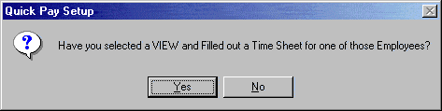

Next the Quick Pay list box will be displayed with the employee types (Salary, Hourly or Both) selected.

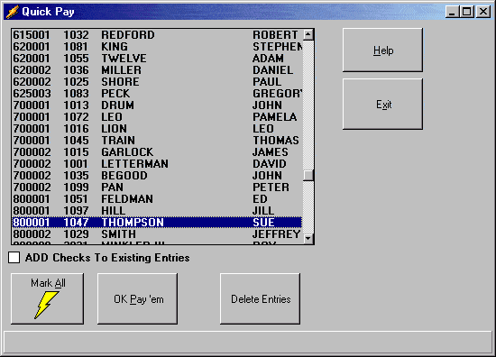

Now you can select the rest of the employees you want to pay. If all of the employees listed are to be paid, click the “Mark All” button. All the employees will be highlighted. To select individual employees to pay, hold down the Ctrl key and then click on each employee; clicking on an employee that is already highlighted will deselect them. To highlight a contiguous block of employees click on the first employee in the range, then hold down the Shift key and click on the last employee in the range. After the employees have been selected, click the “Ok Pay’em” button. A warning message will appear informing you that this action will overwrite previous pay entries made for these employees.

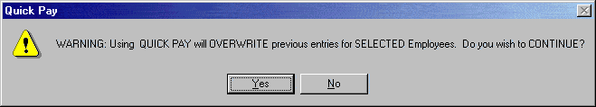

If this is a regular pay entry, then click “Yes.” If these entries are to be added to any pay entries they already have, the “Add Checks To Existing Entries” option must be checked first. Otherwise, the Quick Pay Entries will overwrite any existing entries.

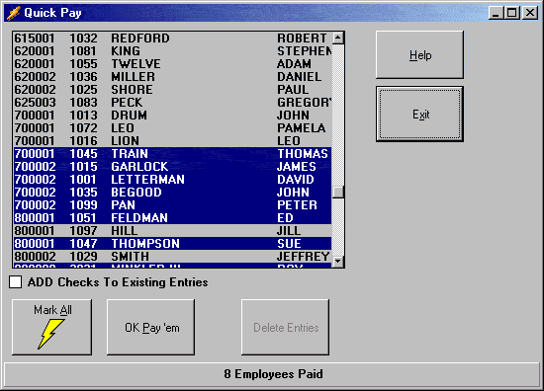

After Quick Pay has completed paying the employees, it will display the number of employees paid in the status line, at the bottom, of the Quick Pay list box. Click the “Exit” button to return to the Time Sheet screen.

The “Delete Entries” button will delete ALL entries for any selected employees. Use with CAUTION.

Hints & Tips

-To pay a salaried employee the only entry needed is an entry code.

-A salaried employee who receives more than one sixty-series entry will need to have zeroes entered in the Temp Rate for each line other than the first. Lines that are not zeroed out, i.e., have zeroes in the Temp Rate; will pay the employee his/her salary AGAIN.

-On a seventy-series check (separate check) for a salaried employee, if an employee is not to receive his/her regular salary, zeroes or an override salary needs to be entered in the Temp Rate for that employee.

-An eighty-series check (separate bonus check) will only take amounts toward the gross from the Other1 (dollar amount) field. Only taxes and DBL will be taken. The DBL deduction (#54) will more than likely need to be zeroed out and if the employee wants any voluntary deductions, such as 401-K, you must “force” that deduction to be taken (Deduction number plus a minus (“-“) sign).

Accrual Balance Checking
Labor Code Timesheet Field
&
Certified Payroll Input

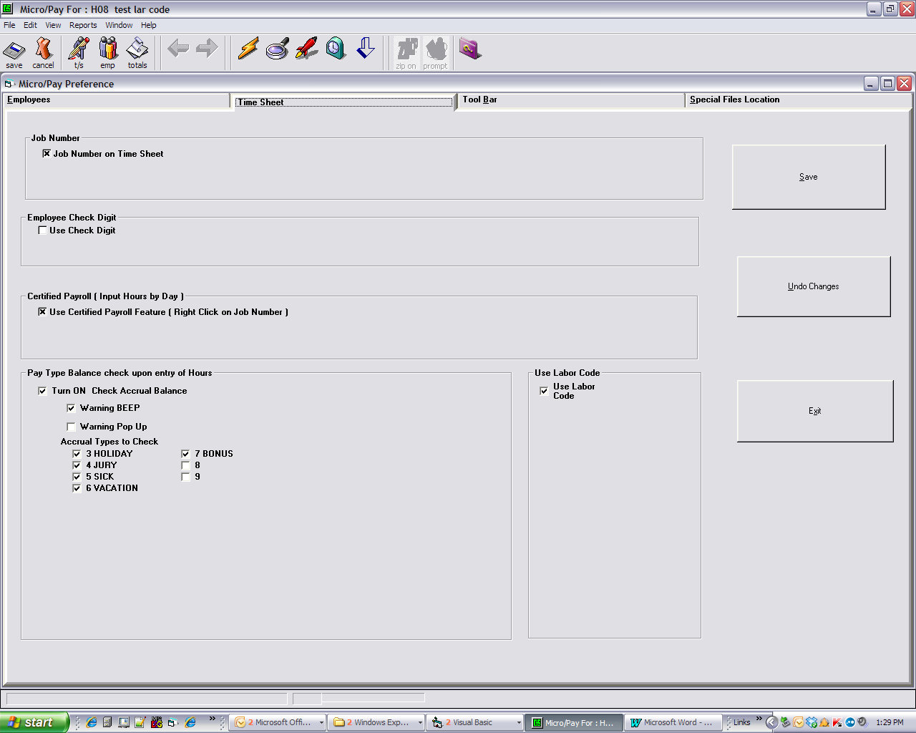
Turn these options on at the preference screen for the timesheet.

Turn on the accrual checking here and its various options. The labor code filed will appear on the timesheet when this is checked. The certified payroll input option is here. They will all be off by default.

Accrual Balance checking
&
Labor Code Field
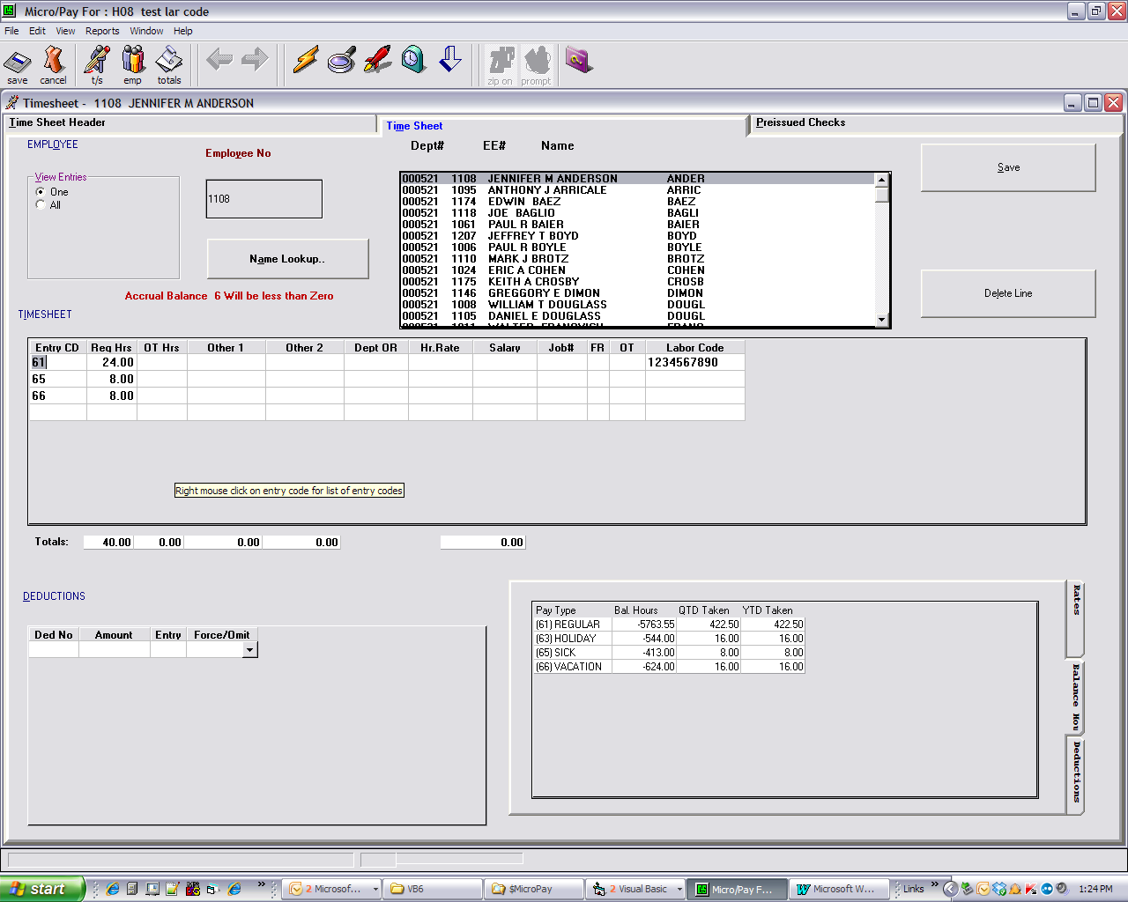

Upon entering an accrued pay type, if the balance will go to zero or less a message will appear here and if you had selected in the preferences a popup message may appear.

Also note the ten character Labor Code field at the end of the row here.

Certified Payroll Input

Put an initial entry code on the pay line. Right mouse click on that lines job number field. This screen will pop up.

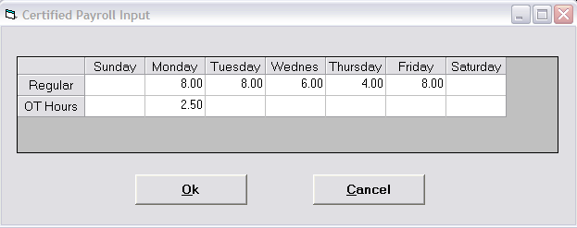
You may enter the hours by day. The timesheet will be filled out like the following:

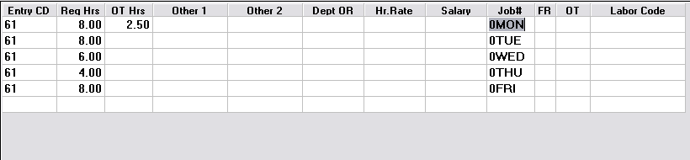
You may make changes as needed or cancel the whole time sheet and start over.

Preissued Checks

Preissues update an employee’s information without producing an actual check. Both Regular and Third Party Sick pay Preissues are entered on this screen. The method for doing each is different.

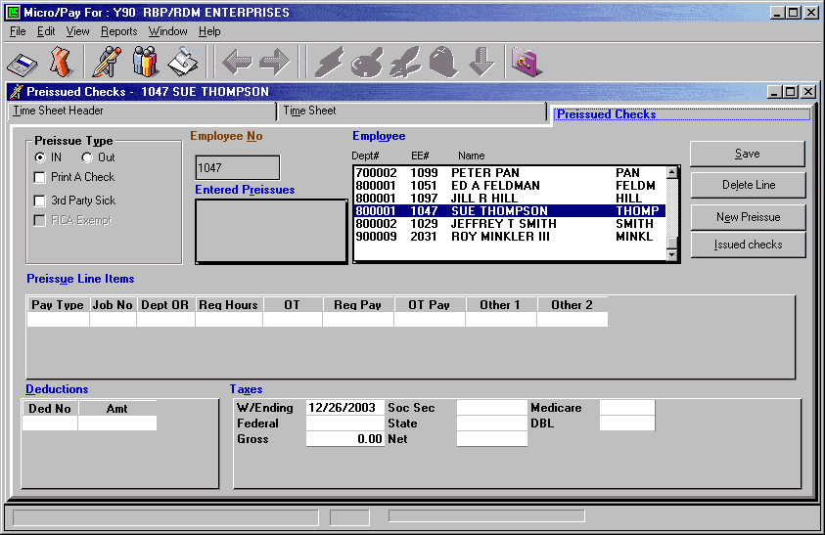

An employee is allowed up to five “In” and five “Out” regular preissues. Each employee may have one “In Preissue” that prints a live check. This feature is useful if you want a check to come out in a very specific way. This preissue is in addition to the maximum five “In Preissues.” For Third Party Sick Pay an employee may have one “In” and one “Out” preissue for taxable and one “In” and one “Out” for non-taxable amounts. “Out Preissues” do not need to be entered with negative numbers; this is handled automatically. A negative number on an “Out Preissue” will be treated as a positive.

On regular preissues the gross pay will be calculated from the line items entered. Then any deductions and/or taxes plus the net pay will need to be entered. These calculations will be checked when the preissue is saved and if it does not crossfoot; a message will appear along with the Net that would crossfoot. Make the necessary adjustments and save again.

Keystrokes and Employee selection function the same for Preissues as they do for the Time Sheet. The special toolbar buttons for the Time Sheet are, however, not available.

Regular Preissues

The first step to enter a preissue is to select an employee. If this employee already has any preissues, they will show up in the Entered Preissues box. To edit one of these preissues double click on it and the information will be brought up. If the employee does not have any preissues, the screen will be brought up ready for a new preissue. Otherwise, to add a new preissue, click the “New Preissue” button.

To enter a new preissue, determine whether this is an IN (add to totals) or an OUT (subtracts from totals) preissue, then select the “IN” or “OUT” button under Preissue Type, in the upper left corner of the screen. If this preissue is to cut a live check, select the “Print A Check” option. Now click in the Pay Type box to start entering your Preissue Line Items for the preissue. All entries for a preissue need a Pay Type, otherwise only the fields you need should be filled. Amounts placed in Regular Pay, Overtime Pay, Other 1, and Other 2 fields will add to the gross.

After all your Preissue Line Items have been entered, enter any deductions as necessary. To access the Deduction area, click in the Deduction area or press Alt-D. Enter the Deduction Number and Amount for any deductions.

Finally, enter any taxes and the Week Ending Date (W/E Date) this preissue will be given. To access the Week Ending Date field, click in the W/E Date field or press Alt-X. Press return to accept the date or enter a new date. Fill each field as needed. The cursor will travel from W/E Date to Soc. Sec., to Medicare then across the second row (Federal, State, DBL) and lastly to the Gross and Net fields. The amount in the Gross field will equal the dollar amounts entered in the Preissue Line Items. If this is not correct, check your entries and make any changes needed. Note: The Gross amount cannot be entered directly. Save the Preissue by clicking the “Save” button.

Third Party Sick Pay Preissues

To start entering a Third Party Sick Pay preissue select the employee that has the Sick Pay entry. If this employee already has any preissues, they will show up in the Entered Preissues box. To edit one of these preissues, double click on it and the information will be brought up. If the employee does not have any preissues already entered, the screen will be brought up ready for a new preissue. Otherwise, to add a new preissue, click the “New Preissue” button.

For a new preissue, select whether this is an IN (add to totals) or an OUT (subtracts from totals) preissue by selecting the “IN” or “OUT” button under Preissue Type, in the upper left corner of the screen. To make this a Third Party Sick Pay, select the “3rd Party Sick” option. If the sick pay is “FICA Exempt,” select this option too.

Click in the W/E Date field or press Alt-X. The cursor will now be in the W/E Date field in the lower right area of the screen. Enter a date for the sick pay or accept the one in the box. If this is FICA Exempt sick pay, the only fields entered are: W/E Date, Gross, and Net. For a nonexempt sick pay, all fields except DBL can be entered. Once all the information has been entered, save the Preissue

Reports

There are six reports built into Micropay: New Employees, Permanent Changes, Time Sheets, Preissues, Banking and Not Paid. These reports are there to provide general information regarding your current payroll. To access these reports, select the Reports menu or press Alt-R.

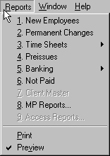

There is an option in the Report menu to select Preview or Print. Preview will display the reports on your screen at which point they can be reviewed and printed out. Print will send the report directly to the printer.

Reports included with Micropay:

New Employees - Creates a one page report with complete information for each new employee entered for the current payroll. When a new payroll has been started any employees entered on previous payrolls are no longer new.

Permanent Changes - Creates a report with that displays any permanent changes made to employees on the current pay period. The report shows the Employee with the old value of the field and the new value given to it.

Time Sheets - The time sheet report resembles the filled in time sheet. It shows the entries made for employees. All fields with an entry are shown for each employee. This report is useful for creating paper copies of your information for your records and/or for checking your entries. Time Sheet reports can be sorted as follows:

1. By Department and Employee Name:

-Lists employees by department and displays department sub totals.

2. By Department, By Employee (Employee Sub Totals):

-Lists employees by department and displays employee sub totals.

3. Summarized By Department:

-Displays summaries by department.

Preissues - The preissue report is similar to the time sheet report except that it displays only the Preissues entered for each employee. Only filled fields are printed on this report.

Banking - There are two options for the banking report: “Pre-noted” or “all.” The “Pre-noted” option allows you to view employees’ accounts that are pre-noted, but not yet active. The second report is for all employees’ banking setups. Both reports show all the banking fields and are sorted by employee number. On the “All” banking report, all of an employee’s bank accounts are shown together.

Not Paid - This report will display employees that have not been paid. If an employee does not receive a pay entry, e.g., a 61 entry code on the time sheet, this constitutes an employee not being paid and thus they will appear on the Not Paid report. This report can be useful when importing information from a time clock. Run the Not Paid report after importing information from a time clock to verify employees have received pay entries.

A custom report option is available for Micropay. Contact ComputerSearch for more information.

Reports Toolbar

At the top of any report’s screen there is the Reports Toolbar. Using the toolbar you can: change the magnification of the display, print the displayed report, export the displayed report as a file or an email, and close the display. Note: The Reports feature of Micropay uses a program called Crystal Reports™. Certain programs use different versions of Crystal Reports™; therefore the type of buttons and placement of the Reports Toolbar may be different on your computer than what is depicted below.

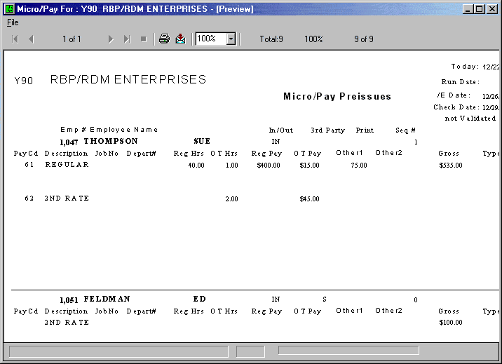

Reports Toolbar Buttons:

Change magnification
Export this report
Print this report
Terminate report generation
Go to last page of report
Go to next page of report
Current page being displayed (of total pages)
Go to previous page of report
Go to first page of report
1. Go To First Page – This button will return you to the first page of a multi page report. It remains inactive (grayed out) while page one is being displayed.

2. Go To Previous Page – Clicking on this button will display the previous page of a multi page report. It is inactive when the first page of the report is being displayed.

3. Page Number – This control shows the user which page is currently displayed and the total page count of the report.

4. Go To Next Page – Clicking on this button will display the next page of a multi page report. It is inactive when the last page is being displayed.

5. Go To Last Page – This button will display the last page of a multi page report. It remains inactive (grayed out) when the last page of the report is being displayed.

6. Terminate Report Generation – Occasionally the user may realize that the wrong report has been selected. This button provides the ability to cancel the report generation process. This can be very useful when the mistakenly selected report is taking a long time to generate.

7. Print Reports - This button will print the displayed report. When this button is clicked, it will bring up the print dialogue box. You can choose to print “All” pages of the report or a selected range of pages. You may also select the number of copies and if whether or not the copies should be collated. When you have finished making your choices, click the “OK” button to print the report.

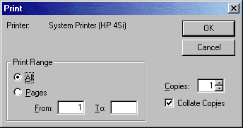

The print dialogue also displays the printer being used. Note: A printer must be setup for your computer in order to view and print any reports. If you want to change the printer you must change the default printer through Microsoft Windows. Consult your Microsoft Windows manual on how to setup a printer.

8. Export Report: The export button provides several methods for exporting the report. Clicking this button will bring up the Export dialogue box shown below.

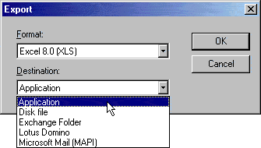

Export to a File
The Export dialogue has two options: Format and Destination. Finished reports can be exported to a number of popular spreadsheet and word processor formats. The Format field allows you to determine the file type such as an Excel, Lotus 1-2-3, MS Word, plain text, Adobe PDF, and others. The Destination option allows you to export directly to a specific program (Application), saved to disk file, saved to Microsoft Exchange Folder, directly to Lotus Domino (v. 3.0+) e-mail client, or to Microsoft MAPI e-mail client. By default “Disk file” is selected. Choose this option to export the report to a file. Click the “OK” button once the desired format has been selected.

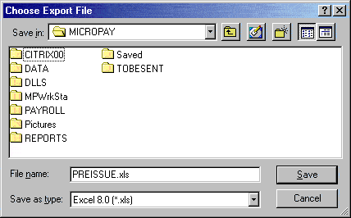

The “Choose Export File” dialogue lets you select the file name and location for the exported report. Select the appropriate Drive and Folder location for the file. Make any desired changes and then click the “OK” button. The displayed report has now been exported to the specified file in the indicated file type.

Export to an Email

The export dialogue also allows you to export a report as an e-mail.
Note: Destination will default to “Disk file.” Click the down arrow, to the right, and select “Microsoft Mail.”

Again, select the desired export format for the report. Then click “O.K.”
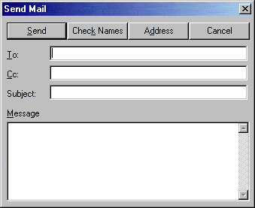

The Send Mail screen will ask for information needed to send an email. Once you have finished filling out this screen, click “send.” Your report has now been sent as an email.

9. Change Magnification - This allows you to select predefined magnifications of the displayed report from a drop-down list. Alternatively any integer percentage value desired may be selected by typing it into the box.

Time Sheet Control Totals

The Time Sheet Control Totals area lets you decide what entries will be included in your totals, check totals for hours, pay and deductions. Also included is Validate Payroll Entries, which prepares your data to be transmitted to ComputerSearch. To access this area go to the Edit menu and then select Control Totals, press Ctrl-N or the Totals button.

Setup Control Totals

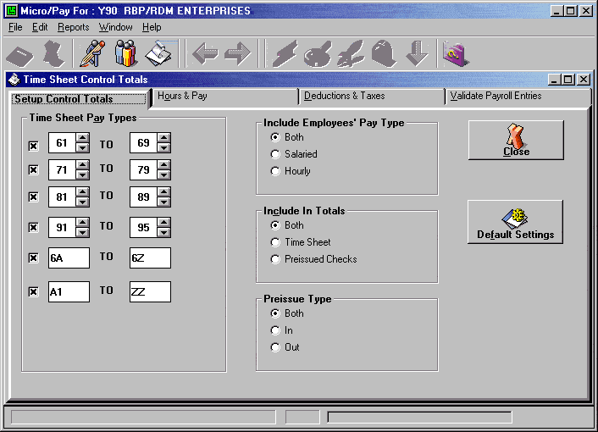

This screen will allow you to pick which entry codes are added to the totals and the pay types (Salaried or Hourly). You may also choose to have the time sheet entries in the total only or the Preissues only, or both. If you decide to have the Preissues count in the totals, “IN” or “OUT” Preissues may be selected.

Hours & Pay

This screen displays the calculated totals for: Regular Hours, Overtime Hours, Other #1, Other #2, Temp Rate, Regular Pay and Overtime Pay. There is a column called “My Totals,” where the totals may be entered manually. Clicking the “ReCalculate” button will display the difference between “My Totals” and “Computed” totals. If changes are made to any of the total entries, the “ReCalculate” button will need to be clicked again to see the changes. Also displayed here are the Number of Checks issued and the Number of Preissued Checks.

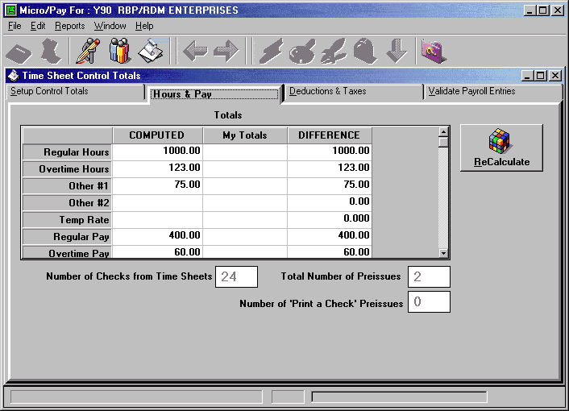

Deductions & Taxes

This screen displays the calculated Deduction totals for each Deduction field. There is also a column called “My Totals” where totals may be entered manually. Clicking the “ReCalculate” button will display the difference between My Totals and Computed totals. If changes are made to any of the total entries, the “ReCalculate” button will need to be clicked again to see the changes. Also displayed on the Deduction & Taxes screen is a computed Grand Total; this value may be entered manually under the “My Totals” column. Again, clicking the “ReCalculate” button will recalculate the totals.

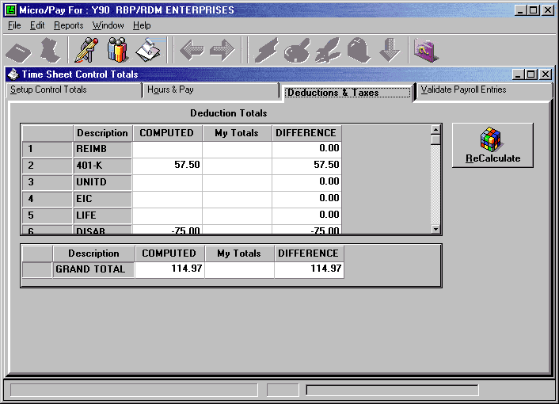

Validate Payroll Entries

This screen is used to prepare the payroll data for transmission to ComputerSearch. Click the “Begin Validation” button on the screen and wait until the validation process is finished. Once the validation process has finished the “Payroll Status” window will display “Validated.” The payroll is ready for transmission. Click the “Transmit” button to go to the Communications area.

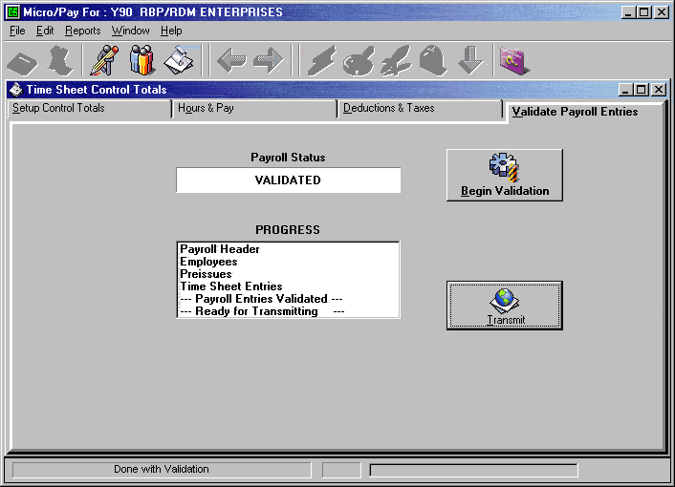

Validate, then Click Transmit or if you have more than one payroll you may wish to finish up the others and transmit all the payrolls together.

Preview Payroll Journal

Preview allows you to send a validated payroll and receive back a preview journal. A payroll may be validated for preview at any point. It is totally optional to do the preview. You will send the payroll wait about 4 minutes, and receive your journal, which may be viewed for errors. You may correct the errors and resubmit again for preview.

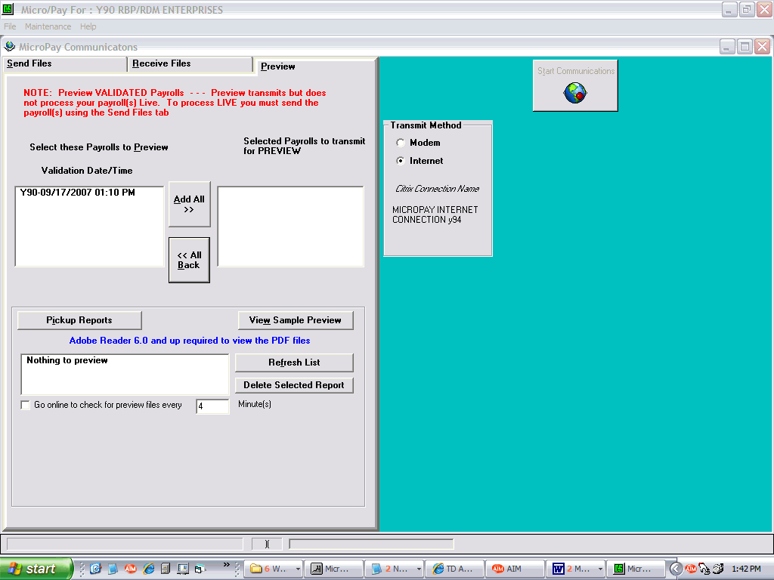

Click Add All or click individual payrolls. Click Start Communications. The ‘Go online to check for preview...’ box will be checked for you and 4 minutes will count down before the program automatically checks for the preview journal that ran at ComputerSearch.

Please close Adobe reader before sending another preview to ComputerSearch.

When the preview journal is ready for viewing you will see the PDF file listed in the box above the ‘Go online…’ check box. Double click on it to open the journal in Adobe reader.

Transmit the Payroll

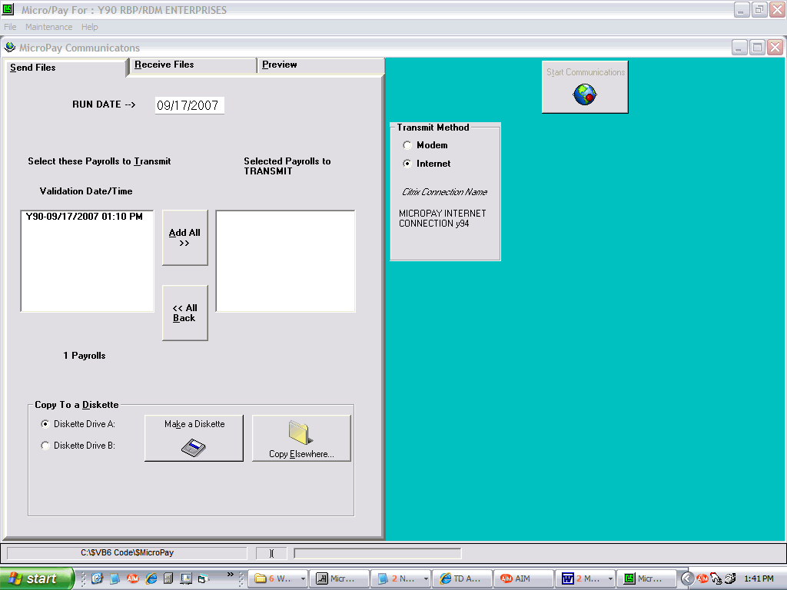

Click 'Add All' or if you have more than one payroll you maybe wish to send one by clicking on the payroll or click the 'Add All' button. The payrolls in the 'Selected Payrolls to TRANSMIT' box are the ones that will be sent. Click Start Communications when ready. You may change the RUN DATE that ComputerSearch will run the payroll on.

Confirmation Numbers

When transmitting your payroll for processing, you will receive a confirmation number and completion status.

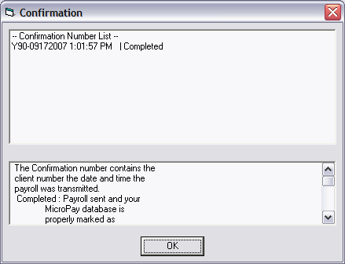

The Confirmation number contains the client number the date and time the payroll was transmitted.

Completed: Payroll sent and your
Micropay database is
properly marked as
transmitted.

NOT Completed: Payroll sent but the
Micropay database is not
marked as such. You will
not see the 'New Payroll
button' when you want to
start a new payroll.

NO CONFIRMATION: Payroll NOT SENT, try
sending again.

Note: You may review this list again on
the client selection screen (the
screen after entering your password)

The Client logon screen will now show if the payroll is Validated, the confirmation status or normal (you will just see the client number and name). Normal means you are working on the payroll.

Receive Files

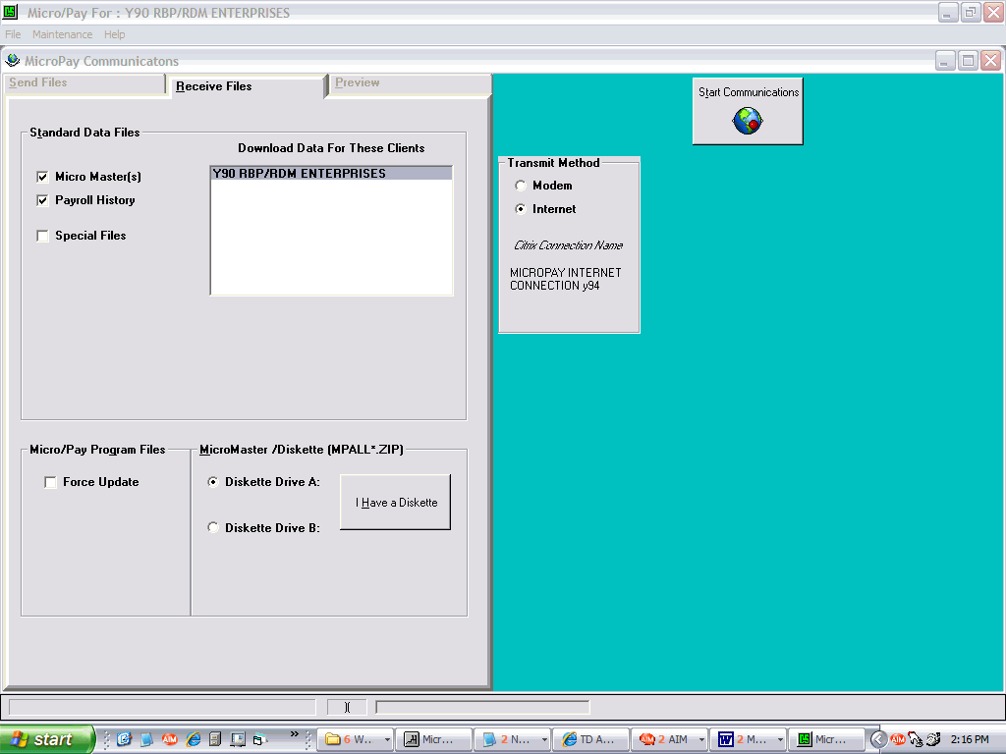

When the payroll is processed at ComputerSearch your updated files are created. These files are ready the day after you have sent the payroll. If you had sent the payroll on Friday the files are ready on Tuesday as we do not normally process the payrolls till Monday. Check off the Micromaster and Payroll History. Some clients may receive ‘Special Files’, if so check the Special Files box. Click Start communications to receive these files.

They may be times when you might be told to only check the force update check box by someone at ComputerSearch. This is mostly used to make sure you can communicate with us and does nothing to your data file. You may use this option on your own to check your connection with us. The option will only update your programs and report files, if needed.

Micropay Communications

To access the Micropay Communications area, go to the File menu and select the Send/Receive option or on the Validate Payroll Entries screen click the “Transmit” button. The Micropay Communications screen performs the following functions: the Communication process (send or receive files), making a diskette, and configuring the data connection to ComputerSearch.

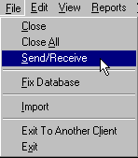

On the menu bar of the communications screen is the Maintenance menu. In this menu are two choices: Citrix Program Neighborhood and Edit Micropay INI. The Citrix Program Neighborhood provides access to the settings Micropay uses within the Citrix data communications protocol. The Edit Micropay INI option allows you to display and modify the settings in the Micropay initialization file. NOTE: Making changes to either the INI file or the Citrix settings should ONLY be done with the guidance of the ComputerSearch technical staff. Making changes here may make Micropay unusable, and/or unable to transmit or receive payroll data.

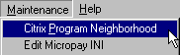

Appendix A – State Codes List

01 Alabama
50 Alaska
02 Arizona
03 Arkansas
04 California
05 Colorado
06 Connecticut
07 Delaware
09 Florida
10 Georgia
51 Hawaii
11 Idaho
12 Illinois
13 Indiana
14 Iowa
15 Kansas
16 Kentucky
17 Louisiana
18 Maine
19 Maryland
20 Massachusetts
21 Michigan
22 Minnesota
23 Mississippi
24 Missouri
25 Montana

26 Nebraska
27 Nevada
28 New Hampshire
29 New Jersey
30 New Mexico
31 New York
32 North Carolina
33 North Dakota
34 Ohio
35 Oklahoma
36 Oregon
37 Pennsylvania
52 Puerto Rico
38 Rhode Island
39 South Carolina
40 South Dakota
41 Tennessee
42 Texas
43 Utah
44 Vermont
45 Virginia
46 Washington
08 Washington, D.C.
47 West Virginia
48 Wisconsin
49 Wyoming

Appendix B - Employee Number Box

The Employee Number box is found on the Time Sheet screen, to the left of the Employee list box. The Employee Number box is also available on the Select tab on the Employee Information screen.

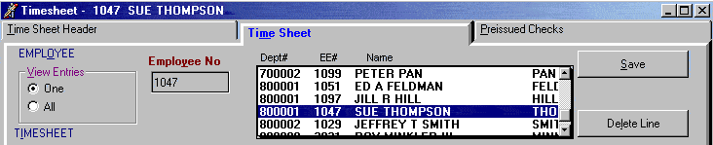

Time Sheet Screen

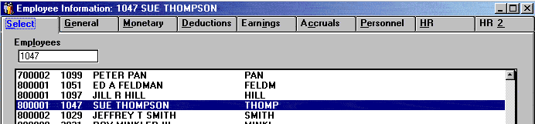

Employee Information Screen

How to Use

Type the desired employee number in the box and press the Enter key. This will display that employee. If the selected employee is not available, an error message will display informing you that they are not in the list.

Normally when the Time Sheet screen is brought up the first employee in the Employee list box will be highlighted and his/her employee number displayed in the employee number box. As you pay each employee, the employee number box will display his or her number.

If you want to use the Employee Number box instead of the Employee list box, to select employees, click in the Employee Number box, enter an employee number and press the Enter key. That employee will then be displayed. The cursor will be positioned in the Entry Code field and you can pay this employee. After you save that entry, the cursor will go back to the Employee Number box. Enter the next employee number and press the Enter key.

Note: The Employee Number box will not display the next employee number of the next employee displayed in the Employee List box. You must enter each employee number.

Selecting Terminated Employees

The Employee Number box, on the Time Sheet screen, only has access to employees that are listed in the Employee List box; normally terminated employees are not listed along with active employees. In order to gain access to terminated employees go to the View menu, then go to the Select option and chose Terminated. This will display only terminated employees and now you will be able to select terminated employees using the Employee Number box.

Index

% Sub Net 23
Accruals 31
Allowed Hours 31
Balance 31
Cycle Code 31
Pay Type 31
QTD/YTD Gross 32
QTD/YTD Taken 32
Adding a New Employee 37
Additional Tax Withheld 23
Auto Tip 23
Bank Codes 16
Banking 25
Cancel Changes 39
Change User Password 8
Change User Security Level 8
Changing an Employee 37
City Codes 17
Client List Box 2
Cobra Data 36
Effective Date 36
Election Flag 36
Notified Date 36
Termination Date 36
Code Tables 14
Bank Codes 16
City Codes 17
state codes 15
Database Functions 3
Fix Database 3
DBL Codes 24
Deductions 28
Amount 29
Balance 29
QTD/YTD Totals 29
Stopping 29
Type 28
Type Codes 28
Week 29
Direct Deposit 25
Earnings 30
EIC Code 33
Employee Information 19
banking 25
CSC name 20
dates 21
direct deposit 25
employee number 20
general 20
hide rate 21
Monetary 22
% sub net 23
additional tax 23
auto tip amount 23
disability 24
exception rate 23
federal exemptions 23
frequency 22
marital status 23
no FICA 24
overtime factor 23
pay rate 22
standard other earning 23
state exemptions 23
third pay rate 23
name 20
prenotification (prenote) 25
social department 21
social security number 20
sort code 21
terminated 21
W2 pension 21
Exception Rate 23
Federal Exemptions 23
Fix Database 3
Frequency 22
H Code 27
Hide Time Sheet Rate 21
HR 34
Cobra Data 36
Emergency Contact Info 35
Last Worked Date 35
Next Review Date 35
Rate Change History 35
Termination Reason 35
HR2 36
Importing Data 4
apply transactions 5
setup 4
spreadsheet 4
time clock 4
Translate 5
Inactivating an Employee 38
Micropay Basics 1
Starting Micropay 1
Next Review Date 35
No FICA 24
Overtime Factor 23
password 6
Pay Rate 22
Personnel 32
EIC Code 33
Last Week Worked 33
Weeks Worked QTD/YTD 33
Preferences
Check Digit 11
Job Number 11
New Employee 10
Special Files Location 13
Time Sheet 11
Preferences 10
Tool Bar 12
security level 6
Standard Other Earnings 23
codes 24
maximum 24
Starting Micropay 1
State Codes 15
State Exemptions 23
Stop Deductions 29
Terminating an Employee 38
Third Pay Rate 23
time clock 4
User Mangement
change password 8
User Management
change security level 8
User Management 6
deleting a user 7
new user 6
password 6
security level 6
user name 6
user name 6
View Menu 18
auto refresh 18
group 18
refresh 18
select 18
sort 18

Exception Rate - Exception Rate (also called Second Rate) allows for paying an employee at two different rates of pay. Exception Rate is always an Hourly Rate and has a maximum value of $99.999. A 62-Entry Code with hours will pay an employee at his/her Exception Rate for those hours. On a salary employee if he or she has Overtime hours and an Exception Rate, that employee will be paid at the Exception Rate times the Overtime Factor times the number of Overtime hours.

Third Pay Rate - Third Pay Rate provides another option for paying an employee. Third Pay Rate is an hourly rate with a maximum value of $999.999. To use the Third Pay Rate, your payroll must be setup for this and a pay type dedicated for the Third Rate. Contact ComputerSearch about this option.

Federal Exemptions - Exemptions may be entered for both federal and state, however only federal is required. Note: If an exemption is not entered for the State Exemption field, the Federal number is used. If no deductions from the Tax table are to be made, enter a 99 in the Exemption fields (State and/or Federal) for the effected tax, e.g., a person having a flat percentage withheld.

Marital Status - Place either an M (Married) or S (Single) in the box for Marital Status.

State Exemptions - Exemptions may be entered for both federal and state, however only federal is required

Percentage of Sub Net (% of Sub Net) - Percentage of Sub Net will deduct a percentage from the Employee’s net after all taxes and other deductions. The number entered will be treated as a percentage. Only whole percentages may be used, no fractional. Valid entries are from 001 to 100. The amount deducted will be placed in deduction 9 (Miscellaneous) on the Payroll Reports.

Auto Tip Amount - Auto Tip Amount allows for an employee’s tips to be calculated on a rate per hour worked basis. The rate entered here will be multiplied by the hours worked to compute the employee’s tips. If an employee is setup for automatic tips and tips are entered on the time sheet, these two figures will be added.

Additional Tax Withheld - Employees may have an additional amount of federal or state tax withheld from their check. Enter the dollar amount of the desired additional withholding in the appropriate box(es) (Additional Federal Withheld box and/or Additional State Withheld box). The maximum amount for additional tax is $9,999.99. If an employee wants to have an additional percentage or flat percentage removed from his/her paycheck, check the “As a Percent” box next to the Additional Tax Withheld box. Enter, in the Withheld (State and/or Federal) box, the percentage needed, e.g., 10.50 would be ten and a half percent. If this is to be a flat percentage (no amount from the Tax tables, just the percentage deducted) make sure to change the Federal Exemptions to 99 for that tax.

Standard Other Earnings - Standard Other Earnings allows you to add an additional amount to an employee’s gross pay on a continual basis. A dollar amount may be entered or using Standard Other Earning Codes (see below) it can be setup as a percentage or a rate. When using the percentage or rate setup, you may wish to use Standard Other Earning Maximum to set the highest amount to be added anytime. The amount added by Standard Other Earnings is placed in the Other2 pay field. The maximum amount for this field is $9,999.99.

Standard Other Earnings Codes can make Standard Other Earnings a rate or percentage.

Codes:
1 - Percent of Regular Earnings A - Only Week 1
2 - Percent of Regular + Overtime Earnings B - Only Week 2
3 - Percent of Gross Pay C - Only Week 3
4 - Rate x Regular Hours D - Only Week 4
5 - Rate x Regular and Overtime Hours

Standard Other Earnings Maximum - Sets the maximum Standard Other Earnings to be added to the gross pay.

No FICA - If an employee is exempt from paying FICA place an ‘X’ in this field. Note: An employee cannot be changed from FICA Exempt to FICA Taxable midyear. Another new employee must be created for him/her. A 1099 employee would be setup for No FICA and would also have a special DBL Code of 9.

City Code - This code is used to indicate that this employee must have a local city tax deducted from their wages. See Code Tables - City Codes for more information.

Disability Insurance (DBL) Code - DBL Codes allows employees to be setup as exempt from NYS disability, State Unemployment Insurance (SUI), or Federal Unemployment Tax (FUTA).

The DBL Codes: X - No Disability, Take SUI and FUTA
2 - Take Disability, No SUI or FUTA
3 - No Disability, SUI, or FUTA
9 - 1099 Employee - No Disability, SUI, or FUTA *

If left blank DBL, SUI, and FUTA are taken normally. * Remember for a 1099 employee he or she also needs to be setup for No FICA. Place code X in the No FICA Box.

Banking

Direct Deposit

The Bank section is used to set up an employee for direct deposit if your client master file has also been setup for direct deposit. If your payroll needs to be setup for direct deposit, please contact ComputerSearch.

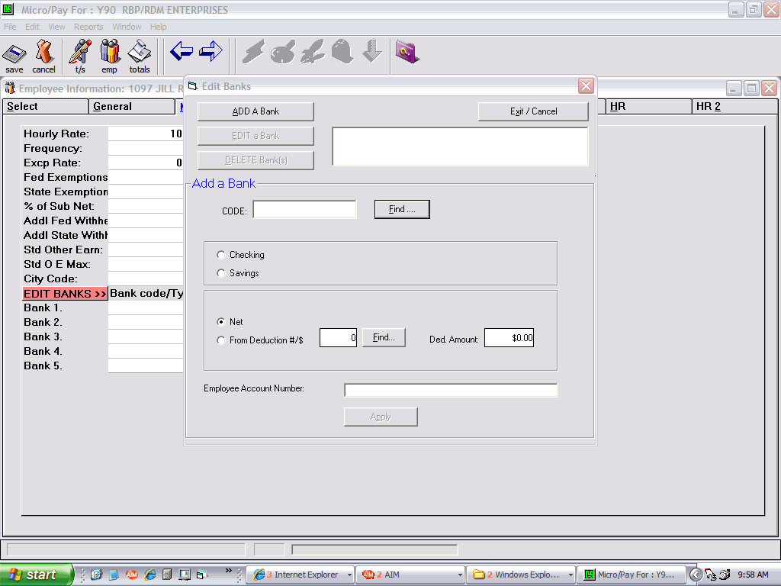

Edit banks button Add a Bank button

How to Setup Direct Deposit

Every time a new direct deposit account is created for an employee it must first go through a prenotification (prenote) cycle. This takes 10 banking days. If there is a problem with the account setup, the bank will contact you about the problem during this period.

To setup an employee for the prenotification cycle, press the 'Edit Banks" button on the employee's Monetary tab then press the 'Add a Bank' button. Start by entering the Bank Code, which is the two character code for the Employee’s bank. You may alternatively enter the transit routing number here, or press the Find… button next to the bank code.

Choose (C)hecking/(S)avings. Note: If an employee can write a check against this account, it is considered a checking account.

Choose either Net or a deduction number and amount. You may use the Find…button to view and choose the deduction. A deduction amount may be set up at this time.

When the prenotification time passes the deduction or the net pay amount will be deposited into the employee's bank account at that time. You will see the effective date after the payroll runs and after you have received your current Micromaster.

Lastly enter the Employee’s bank Account Number in the Bank Account field.

If the Bank reports a problem to you on the prenotification, You must delete the bank using the delete option and add the corrected bank information starting the prenotification process over again.

If there are no problems after 10 banking days, the net pay or the deduction amount will be used as the deposit amount. If everything was set up correctly you will not need to do anything for this to take place.

If, in the future, you need to change the bank or the account number you must delete the bank entry and start a new bank entry and of course go through the prenote period.

You may change the checking or savings option and also change the net pay to a deduction (you may only have one bank entry setup as net pay) or the deduction amount without going through the prenote period.

Monetary Screen after payroll runs

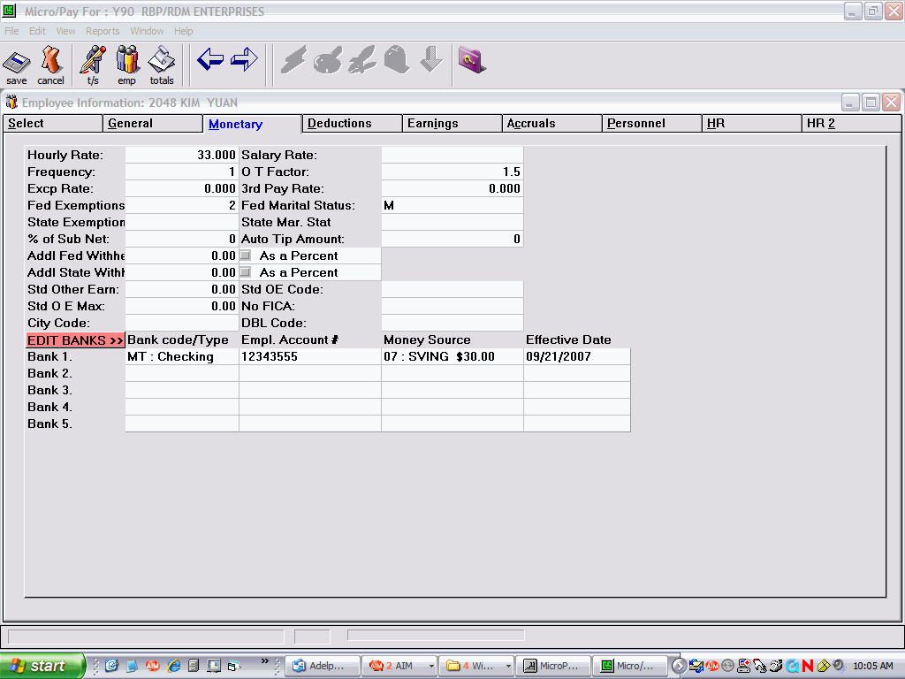

Note: Money Source and Effective Date

Holding a bank for one payroll

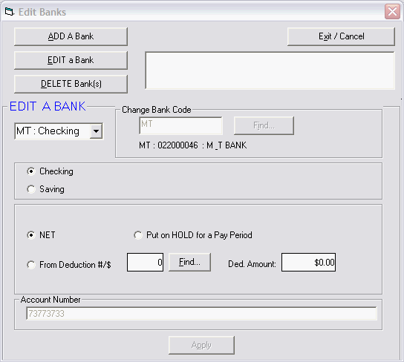

Note: Hold option available for NET PAY type deposits

Should a direct deposit need to be stopped for one pay period, thereby cutting an employee a “live check,” use the 'Hold' option. This option is used only with Net (N) checks, i.e., Net Pay Deposit. Note: This is not a permanent change; the hold is only active for that pay period. After the Micro Master has been downloaded and a new payroll started, the bank will revert to the NET PAY deposit.

Holding a bank with a deduction as the money source

If deductions need to be stopped for that check, go to the Deductions area on the Time Sheet screen, enter the Deduction number in the Ded No field, zero for the amount in the Amount field and select “Omit” in the Force/Omit field. If the Direct Deposit check has a direct deposit deduction, e.g., the check is split between checking and savings accounts, go to the Deductions tab on the Employee Information screen and place zeroes in the Amount field to stop that deduction. Note: The Deduction amount will need to be re-entered for the following payroll.

Deleting a Direct Deposit

Simply choose the Delete button on the Edit Banks Screen and check mark the bank you wish to delete. An asterisk will appear on the monetary screen where the bank code was.

Deductions

The Deductions screen can be used to Start, Stop, or Change an employee’s deduction Amount, Type, Week, and Balance.

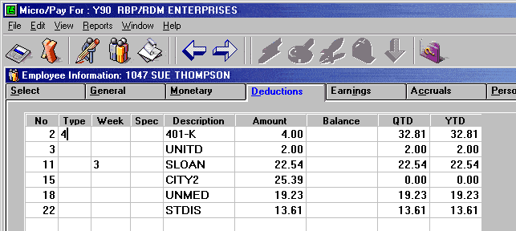

Deduction Type

To setup deductions that are not a simple dollar amount, the Deduction Type will need to be used. The different codes available allow for many ways to set a deduction’s amount. For example, when using a Fractional Percentage Deduction code (7 or F), entering 9.25 in the amount field will cause 9.25% to be deducted.

Deduction Type Codes:
1 - Percent of Regular Earnings
2 - Percent of Regular + Overtime Earnings
4 - Rate x Regular Hours
5 - Rate x Regular and Overtime Hours
6 - Rate x Regular + Rate x (Overtime Hours x Overtime Factor)
7 - Fractional Percentage of Gross
A - Deducts a flat amount and maintains an arrearage balance
B - Percentage of Net Pay after taxes and other deductions, only one B code deduction allowed
D - % of Disposable Income - Child Support
F - Fractional Percentage of Regular, Overtime, and Other1 Earnings
L - Tax Levy
M - Maximum Net Pay
N - Net Pay
R - % of disposable income - Higher Education Loan, Garnishment
S - Substitute Tax Levy

Deduction types may be set up on the Client Master file. Therefore, all employees with that deduction have the type automatically set, i.e., 401-K deductions that are all Percentage of the Gross.

Other more specialized types are available for garnishes and other special situations. Please contact ComputerSearch for more information.

Deduction Week

A number entered in the Deduction Week field will cause this deduction to be deducted on that particular week ONLY. Valid week numbers are 1, 2, 3, and 4.

The “L” Deduction Week code may be entered in the week field. This will cause the deduction to be taken every week except week 5 on a weekly payroll and every week except week 3 on a biweekly payroll. The “M” Deduction Week code will take a deduction on the last week of a month.

Other Deduction Week Codes:

A - Week 1 & 2 D - Week 2 & 3
B - Week 1 & 3 E - Week 2 & 4
C - Week 1 & 4 F - Week 3 & 4
G - Weeks 1 & 2 & 3

Under normal situations, deductions that are for a particular week should be coded on the Client Master. This will control the week of that deduction for all employees.

Deduction Amount

The maximum amounts for deductions in the Deduction Amount field are:

Deductions 1 - 8 is $99,999.99
Deductions 11 - 49 is $9,999.99

Stopping Deduction

Entering zero in the Deduction Amount field will stop the deduction for an employee.

Deduction Balance

The amount of the deduction is subtracted from the Balance, per pay period. If the Balance is lower than the amount of the deduction, then just the remaining balance is taken. Once a deduction Balance reaches zero the deduction is automatically stopped. The maximum amount for a Balance field are Deductions 1 - 18 is $99,999.99
Deductions 21 - 49 is $9,999.99

Quarter To Date / Year To Date

The last two columns on the deductions screen display the Quarter and Year to date totals of each deduction for the selected employee.

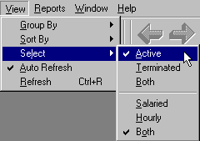

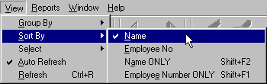

Employee Information Screen

This is the Employee Information screen. To access this screen, click the “Employee” button on the tool bar. This screen allows you to Add New employees, View and Change employee information. The following section will explain the various features of the Employee Information screen.

When this screen is accessed the Select tab will be displayed. This area allows you to select individual employees. You may change the sorting and grouping methods for displaying employees from the View menu. See “View Options” above for more information on this subject.

General Information

This is the General Information screen for an employee. Basic information such as Name and Social Security Number are entered here. To access this screen, click on the General tab. Error checking for this screen is done when the data is saved, not as it is entered.

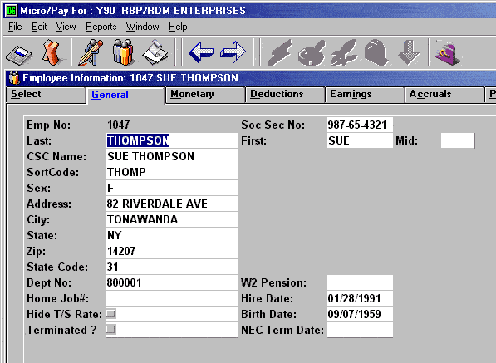

Employee Number - This is a display only field. Every employee must be assigned a unique number from 1 to 9997. This number is assigned when a New employee is added and cannot be changed.

Social Security Number - The employee's social security number may be viewed, entered or changed in this field.

Last Name - This field has a 20 character limit including spaces apostrophes and hyphens.

First Name - This field has a 12 character limit including spaces apostrophes and hyphens.

Middle Initial- Only one character may be entered in this optional field.

CSC Name - This is how employee names will appear on reports and checks issued by ComputerSearch. This field has a 20 character limit (including spaces). Therefore it will be necessary to abbreviate first and middle names. This field will be automatically updated any time a change is made to the other name fields; however the user may edit this field after it has been auto-updated.

Sort Code - Sort Code is used to order employees on reports. Normally it is the first five characters of an employee’s last name, i.e., Washington would have a Sort Code of WASHI. If two employees have the same last name, you may wish to make the last character of the Sort Code the first letter of their first name. For example, John Smith and Steve Smith could have SMITJ and SMITS for their Sort Codes respectively. Alternatively, Employee Numbers may be used for the Sort Code.

Sex - Employee gender may be indicated in this field using either "F" or "M".

Address Information - The Address, City, State, and Zip fields allow for maintaining employee home addresses.

State Code - This field indicates which state this employee is earning their income in for tax purposes. See the Code Tables - State Codes for more information.

Department Number - This optional field shows the "home" department that this employee belongs to. This information is used in sorting and grouping employees for reports.

W2 Pension - Enter an "X" to indicate that this employee is participating in a pension fund, which must be indicated on their W2 form.

Hide Time Sheet Rate - You may choose whether an employee’s rate of pay is shown on the Time Sheets delivered from ComputerSearch. If this box is checked, the employee’s rate will not be printed.

Terminated - The Terminated Employee field is for display only, see Terminating an Employee later in this section.

Employee Dates - There are three different dates available per employee: Hire Date, Birth Date, and Term Date. These dates are entered in MM/DD/YYYY format. The date information can be typed into the box, or double clicking in the box will cause a calendar tool to appear.

Monetary

The Monetary screen shows the items that determine how an employee receives their pay. This includes the various rates of pay, pay type, and frequency. Tax and direct deposit information are included on this screen, as well.

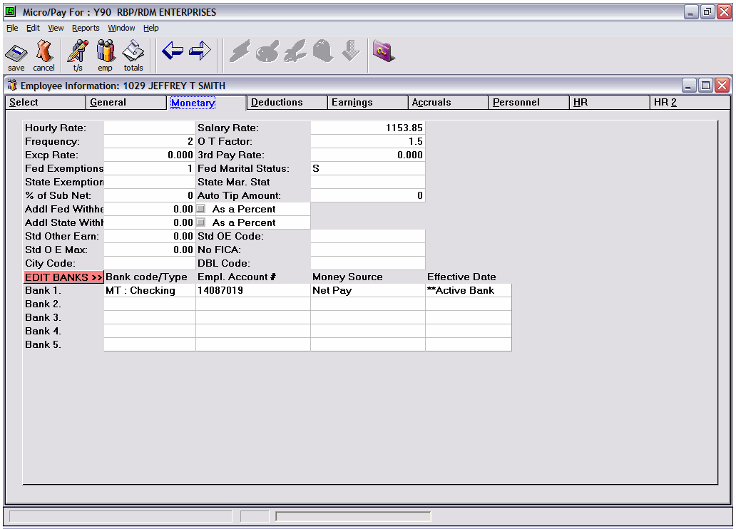

Pay Rate - Fill in either the Hourly Rate or Salaried Rate fields as the Employee’s normal rate of pay. An employee cannot have both. The Hourly Rate has a maximum value of $9,999.999. A Salaried Rate has a maximum value of $99,999.99. Note that the Hourly Rate has three decimal places, whereas the Salaried Rate has only two.

A Frequency, for how often an employee is paid, must be entered for each employee.
Frequency codes are: 1 - Weekly
2 - Bi-Weekly
3 - Semi Monthly
4 - Monthly

Each employee also needs an Overtime Factor (also called Overtime Weight) to determine how their Overtime is computed. Any factor from 00 through 99 can be used. Example Overtime Factors:
00 - Non-Paid Time
05 - Half Time
10 - Straight Time
15 - Time and a Half
20 - Double Time
25 - Double Time and a Half
Etc.

