Micropay Reports
Manual
ComputerSearch Corporation
331 John James Audubon Parkway
Amherst, New York 14228

Phone 716-689-0511
N. F. 716-692-1409
Fax 716-689-1532

Table of Contents

Logging on to Micropay Reports 1
How to Run a Report 2
Reports 4
Alpha Employee List 4
Alpha Time Sheet 4
Deduction Report Summary 4
Employee Dates 5
Employee Hired/Terminated 5
Employee Report 5
Employee YTD Sick 5
Employee YTD Vacation 5
History Earnings By Employee 5
Quarterly Department Report 6
Rates By Department 6
Sick-Vacation Report 6
Unemployment Report 6
Report Parameters Screen 8
Report Selected 8
Employees 8
Deductions 8
Pay Codes 9
Departments 9
Entering Dates 9
Employee Dates 9
History Dates 9
Reports’ Toolbar 10
Reports’ Toolbar Buttons: 10
Export Screen 11
Exporting to a File 11
Exporting to E-mail 12
Utilities Menu 13
Check Employee/YTD Gross 13
Quick Lists 14
How to Build a Report 14
Special Cases 17
Current Terminated Employees 17
Dropped Terminated Employees 17
Index 18

Logging on to Micropay Reports

Double click on the icon on your desktop or go to the Start menu, select Programs, then select the Micropay folder, highlight Micropay Reports and click the left mouse button. The logon screen will look the same as the one for Micropay. Micropay Reports is accessed by the same User ID and Password used by Micropay and will immediately display the Micropay Reports Selection screen (figure 1).
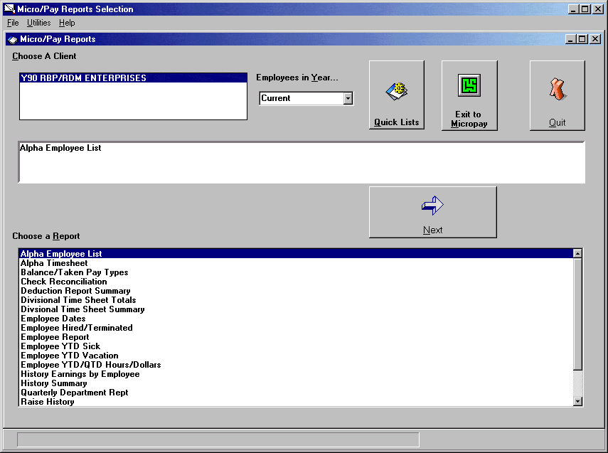
Figure 1
From this screen you select which report you want to run from the list of reports displayed here. See the Reports section for details about the list of available reports.

How to Run a Report
There are four steps involved in generating a report.
- Choose a client
- Select a report type
- Select the report parameters
- Click “Print/Preview” to generate the report

These steps are illustrated in the “History Earnings by Employee” report example below.

1. Choose a client: Most ComputerSearch clients have only one payroll and therefore only one client is listed. If you have multiple payrolls then you will see more than one client listed. Select the client for the report by clicking on the client name. The name will become highlighted.

2. Select a report: Only one report may be run at a time. Here we have chosen the “History Earnings by Employee” report. For more information on the reports see the Reports section. Click the “Next” button to proceed to the Report Parameters Screen (figure 2). If you have selected the wrong report or client you may click the “Back” button on the Report Parameters Screen to return to the Report Selection screen.
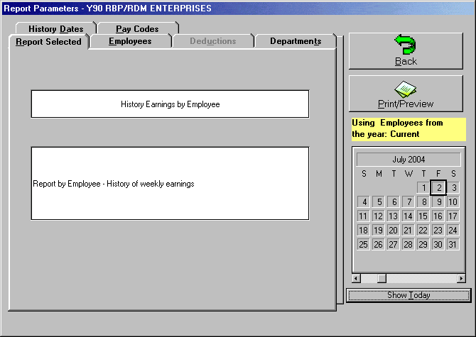
Figure 2

3. Select Items to display: On the Report Parameters screen, select the items to be displayed on the report. The “History Earnings by Employee” report allows the following parameters:
- Employees: defaults to “All Employees”, a group of one or more specific employees may be displayed by selecting them from the list. All highlighted employees in the list will be displayed in the report. Clicking on an employee a second time will deselect them. A single employee may be selected by typing their employee number in the provided field.
- Pay Codes: defaults to “All Pay Codes.” One or more pay codes may be select from the pay code list by clicking on the desired item. All highlighted items in the list will be displayed in the report. Clicking on a list item a second time will deselect it.
- Departments: defaults to “All Departments.” To display particular departments select them from the department list by clicking on them. A single department may be selected by typing its number in the provided field.
- History Dates: defaults to the “Current Pay Period” date range. The History Date range uses either the Week Ending Date or the Check Date. The default value used for the Date range is the Week Ending Date. You can change the date range parameter to display last pay period, current month, current quarter, current year, or you can specify a date range.

For more information on the parameters see the Report Parameters section.

4. Click the “Print/Preview” button: This will generate a preview of the report with the specified parameters (figure 3). Clicking the “printer icon” button will bring up a print dialog box, where you can print out the entire report or a range of pages and the number of copies. Micropay Reports uses the default printer that is setup for Microsoft Windows; consult your Microsoft Windows manual for details on setting up a printer. When finished, click the “close” button to return to Micropay Reports Selection screen. Note: Each report is defined to print in either Portrait or Landscape mode and cannot be changed.
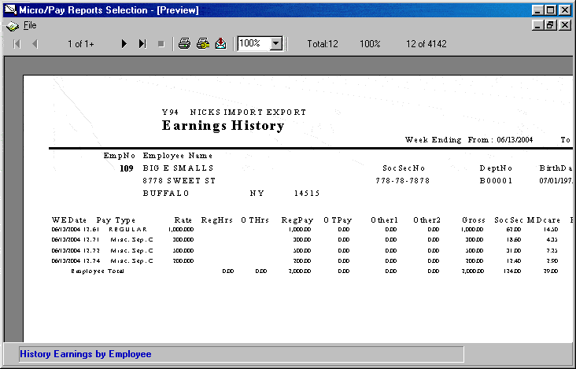
Figure 3

Reports
Micropay Reports has many built in, predefined reports. The following gives a brief description of some of the more commonly used ones.

Alpha Employee List
This report generates an alphabetically sorted list of employees with the following information:

Employee Number, Employee Name, Department Number, Department Name, Terminated Date, and Date Hired. The last page of the report will indicate the total number of employees on this report.

Note: The data used in the Alpha Employee List is stored in the MicroMaster. Therefore it is essential to download the MicroMaster.

The Departments tab is available for this report.

Once the appropriate parameter has been selected, click the “Print” button to display this report.

Alpha Time Sheet
This report displays information from the Micropay Time sheet. When a new payroll is begun, this report will have no information. As each employee is paid, this report will display that information sorted in alphabetical order. The Alpha Time Sheet report displays the following information:

Week Ending Date, Reset MTD Totals, Check Date, Starting Check Number. This information is taken from the Time sheet Header.

Line one: Employee Number, Employee Name, Home Department, Salary Rate, Hourly Rate, 2nd Rate, and 3rd Rate.

Line two: Pay Code, Description, Job Number, Hours, Overtime Hours, Other1, Other2, Department Number, TempHourly, TempSalary, Frequency, Overtime, Deduction Number, Deduction Description, and Deduction Amount.

The report also displays the entered Run Date of the payroll, whether the payroll has been validated and if it has been transmitted.

No parameters are available for this report. Click the “Print” button to display this report.

Deduction Report Summary
This report will display the following information for the deduction selected:

Employee Name, Employee Number, Social Security Number, Deduction Amount, YTD Amount, and Grand Total.

The YTD Amount lists information for the current year only! For example, if a 1999 date range is selected, the YTD Amount will only list information from January 2000 to the current date.

Note: The information for the Deduction Report Summary uses information stored in the MicroMaster and Payroll History files. Therefore it is essential to download these files.

All tabs are available for this report. Once the appropriate parameters have been selected, click the “Print” button to display this report.

Employee Dates
This report will display Date Hired, Terminated, and Birth Dates for each employee. Also on the report are the Employee Name and Employee Number. This information is sorted alphabetically.

The Employees and Employee Dates tabs are available for this report. Once the appropriate parameters have been selected, click the “Print” button to display this report.

Employee Hired/Terminated
This report displays an employee’s Date Hired and Terminated date. The report also contains the Employee Name, Employee Number, and Social Security Number of the selected individual(s). This information is sorted alphabetically.

The Employees, Departments, and Employee Dates tabs are available for this report. Once the appropriate parameters have been selected, click the “Print” button to display this report.

Employee Report
This report gathers employee information from the Employee Information Screen in Micropay. The report displays information for the selected individual(s) from the following sections: General, Monetary, Deductions, Earnings, Accruals and Personnel.

Note: The information for the Employee Report uses information stored in the MicroMaster. Therefore it is essential to download the MicroMaster.

The Employees and Departments tabs are available for this report. Once the appropriate parameters have been selected, click the “Print” button to display this report.

Employee YTD Sick
This report displays the Year-To-Date totals for Sick Hours taken, the remaining Balance Hours, and Grand Totals for both. The report is sorted alphabetically by name and also gives the employee number.

Note: The information for the Employee YTD Sick report uses information stored in the MicroMaster. Therefore it is essential to download the MicroMaster.

The Employees and Departments tabs are available for this report. Once the appropriate parameters have been selected, click the “Print” button to display this report.

Employee YTD Vacation
This report displays the Year-To-Date totals for Vacation Hours taken, the remaining Balance Hours, and Grand Totals for both. The report is sorted alphabetically by name and also gives the employee number.

Note: The information for the Employee YTD Vacation report uses information stored in the MicroMaster. Therefore it is essential to download the MicroMaster.

The Employees and Departments tabs are available for this report. Once the appropriate parameters have been selected, click the “Print” button to display this report.

History Earnings By Employee
This report displays a History earnings report for each employee, plus a grand total for all employees. Each employee record contains: Employee Number, Employee Name, Employee Address, Social Security Number, Department Number, Birth Date, Date Hired, Date Terminated, Week Ending Date, Pay Type, Rate, Regular Hours, Over Time Hours, Regular Pay, Over Time Pay, Other1 Earnings, Other2 Earnings, Gross Pay, Social Security Taxes, Medicare Taxes, Federal Withholding, State Withholding, Disability Insurance, All Deductions, Net Pay, and Employee totals. The last page of the report displays the Grand Total for all employees.

Note: The information for the History Earnings By Employee report uses information stored in the Payroll History file. Therefore it is essential to download this file.

The Employees, Departments, and History Dates tabs are available for this report. Once the appropriate parameters have been selected, click the “Print” button to display this report.

Quarterly Department Report
This report displays the following department information: Charged Department Number, Charged Department Name (where available), Quarter, Regular Hours, Over Time Hours, Vacation Hours, Other Hours, Regular Earnings, Over Time Earnings, Vacation Earnings, Other Earnings, Other Earnings 5, Gross Pay, FICA (Social Security Taxes & Medicare Taxes) Federal Taxes, State Taxes, Voluntary Deductions, and Net Pay. Each department has a department total for each quarter and a grand total for all departments on the last page of the report.

Note: The information for the Quarterly Department report uses information stored in the Payroll History file. Therefore it is essential to download this file.

The Departments and History Dates tabs are available for this report. Once the appropriate parameters have been selected, click the “Print” button to display this report.

Rates By Department
This report displays the employees’ rate of pay listed by department. The report contains the Department Number, Department Name, Employee Number, Employee Name, Salary Rate or Hourly Rate, Exception Rate, and Third Pay Rate.

Note: The information for the Rates By Department report uses information stored in the MicroMaster. Therefore it is essential to download the MicroMaster.

The Employees and Departments tabs are available for this report. Once the appropriate parameters have been selected, click the “Print” button to display this report.

Sick-Vacation Report
This report displays employees Year-To-Date totals for Sick Hours taken, Sick Pay, Balance of Sick Hours, Vacation Hours taken, Vacation Pay, Balance of Vacation Hours, and Grand Totals. The report is sorted by Employee Number.

Note: The information for the Rates By Department report uses information stored in the MicroMaster. Therefore it is essential to download the MicroMaster.

The Employees tab is available for this report. Once the appropriate parameters have been selected, click the “Print” button to display this report.

Unemployment Report
This report displays information for Unemployment / Workers’ Comp Claim. The report contains the following employer information: Employer Address, Federal ID, and Employer Registration Number. Employee information displayed is as follows: Employee Number, Employee Name, Employee Address, Social Security Number, Date Hired, Date Terminated, Department Number, and Birth Date.

Payroll information the report contains: Week Ending Date, Pay Type, Sick Hours, Gross Pay, Gross Pay Less than $80, Employee Totals (for Sick Hours, Gross Pay, Gross Pay Less than $80), Number of Pay Periods, and Average Earnings. This report is sorted by employee number.

Note: The information for the Unemployment Report uses information stored in the Payroll History file. Therefore it is essential to download this file.

The Employees and History Dates tabs are available for this report. Once the appropriate parameters have been selected, click the “Print" button to display this report.

Report Parameters Screen
The Report Parameters screen has six tabs (figure 4):
Figure 4
Not all of the tabs are available on every report. The available parameters depend on which report has been selected.

Report Selected
The Report Parameters screen defaults to the Report Selected tab. This tab displays the Report you selected. If this is not the correct report, click the “Back” button to select the appropriate report.

Employees
The Employees tab allows you to perform the following tasks:
- Display all employees (active, terminated, or both).
- Select one or many employees from the list. All highlighted items in the list will be displayed in the report. Clicking on a list item a second time will deselect it.
- Sort the list by employee Number (Sort by Emp Number) or Employee Name (Sort by Emp Sort Code).
- Select a single employee by entering the Employee Number.

Deductions
The Deductions tab allows you to select a deduction from a list of deductions. Only one deduction may be included on a report.

Pay Codes
The Pay Codes tab allows you to select all, one, or several pay codes from the pay code list by clicking on the desired item(s). All highlighted items in the list will be displayed in the report. Clicking on a list item a second time will deselect it.

Departments
The Departments tab allows you to set the following parameters for a report:
- Display all departments.
- Select one or many particular departments from a list. All highlighted items in the list will be displayed in the report. Clicking on a list item a second time will deselect it.
- Enter a specific department number.

Entering Dates
The date tab allows you to use either employee related dates (Hire, terminate, birth) or history dates (earnings history) as selection criteria. The Employee and History Dates parameters will allow you to specify your own date range. You can enter the dates manually in each field, use the calendar, or double click in each field to bring up a calendar.

The calendar has the current date highlighted by default. To select a range of dates click on one of your end dates (from or to) and hold the mouse button down while dragging the pointer to the other end date, then release the button. Alternatively you can double click in the “from” or “to” fields and a calendar will pop up. Select the desired date by clicking on it, and then click the “OK” button.

Employee Dates
The Employee Dates tab allows you to set the following parameters for a report:
- Date Hired.
- Date Terminated.
- Date of Birth.
- All Dates (labeled “Don’t Select Any Dates”).
- Date Range. A date range must be specified for the following date parameters:
Note: Employee Dates are taken from the MicroMaster.

History Dates
The History Dates tab allows you to set the following parameters for a report:
- History date ranges using Week Ending Dates.
- History date ranges using Check Dates.
- Dates Ranges:
Current Pay Period.
Last Pay Period.
Current Month.
Current Quarter.
Current Year.
Specified Date Range.
[Note: History Dates are taken from the Payroll History file.]

Reports’ Toolbar
At the bottom of the Reports Preview screen there is the Reports Toolbar. Using this toolbar you can change the magnification of the display, print the report, export the report as a file or an email, or close the display. Note: The Reports feature of Micropay Reports uses a program called Crystal Reports™. Certain programs installed on your computer use different versions of Crystal Reports™, therefore the type of buttons and placement of the Reports Toolbar may be different on your computer than what is depicted.

Once a report has been generated, a preview screen appears displaying that report (figure 3). From this screen you may view, print, export or close the report.

Reports’ Toolbar Buttons:
The Reports Toolbar has 6 tools as illustrated:

The table below describes the function of each of the tools.
Move Ahead / Back 1 Page |  | The plain arrow buttons allow you to move through the displayed report one page at a time in the direction indicated. If the button is gray instead of black it indicates that you are at the end of the document and can proceed no further in the indicated direction.
Go To First/ Last Page |  | The arrow and bar buttons will display the first or last page of the report without having to preview each page. If the button is gray instead of black it indicates that you are at the end of the document and can proceed no further in the indicated direction.
Printer |  | When this button is clicked, it will bring up the print screen. The print screen displays the name of the printer being used and allows you to choose to print “All” the pages or a selected range of them. The number of copies to be printed and optional collation of the output may also be selected. After making your choices, click the “OK” button to print the report (Figure 4).
Printer Setup |  | This tool allows you to set certain printer specific parameters before printing. Note that you cannot change page orientation (landscape, portrait) for the predefined reports.
Export Button |  | Micropay Reports provides you with the ability to save the reports you generate in many different file formats including Excel, Word, and plain text.
Zoom Tool |  | This tool allows you to select the magnification of the displayed report. This tool does not have any effect on the printed output.

A printer must be setup in order for you to print or view any reports. Micropay Reports uses the default printer that is setup for Microsoft Windows. In order to change the printer you must do so through Microsoft Windows. Consult your Microsoft Windows manual on how to setup a printer. Note: Each report is predefined to print in either Portrait or Landscape mode and cannot be changed to the other.

Export Screen
The Letter icon buttons provide the means of making a report accessible by other applications. Clicking on this button will bring up the Export screen (figure 5).
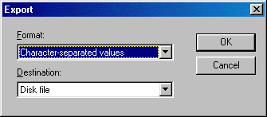
Figure 5

The Export screen has two options Format and Destination. The Format option allows you to save the report as different file formats: such as an Excel, Lotus or Quattro Pro spreadsheet formats, plain text, MS Word format, and others.

The Destination option allows you to choose between exporting the report to a file or as an email. By default “Disk file” is selected which will save the report to the specified file. Optionally you may select “Microsoft Mail” to send the report to your e-mail application.

Exporting to a File
After selecting “Disk File” and clicking “OK” on the Export screen the Choose Export File dialog will be displayed. This screen lets you define where the exported report will be saved. Select the appropriate Drive and Folder location for the file, and enter the desired filename. Make any changes and then click the “OK” button. The displayed report has now been exported to a file.
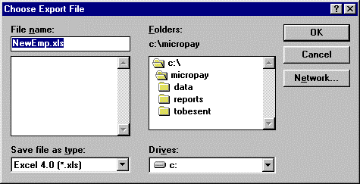
Figure 6

Exporting to E-mail
After selecting “Microsoft Mail” and clicking “OK” on the Export screen the Choose Profile dialog will be displayed. The “Choose Profile” screen will ask you to select a “Profile”. Consult your Microsoft Windows manual about changing the setting or select the default one. Click the “OK” button once the desired file profile has been selected.
Figure 7

The Send Mail screen (Figure 8) will ask you to enter the information needed to send an email. Once you have finished filling out this screen, click “Send”.
Figure 8

Your report has now been sent as an email.

Utilities Menu
The Utilities menu, found on the Micropay Reports Selection screen, contains two options, Check Employee/History YTD Gross and Quick Lists.
Figure 9

Check Employee/YTD Gross
Check Employee/History YTD Gross will display a report with each Employee’s Year-to-Date Gross checked against their History Year-to-Date Gross (figure 10). If a difference between the two amounts is detected, it will be listed in the Difference column. Click the Print button to preview this report. From the preview screen you can print this report.

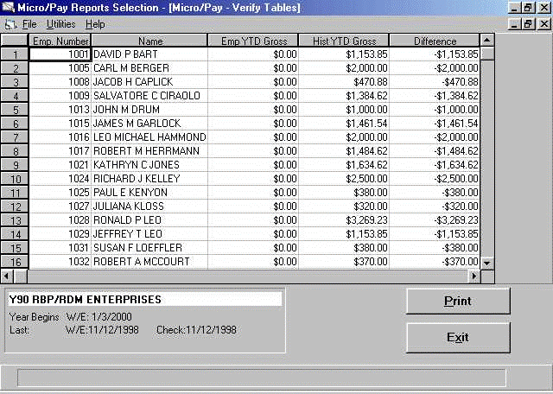
Figure 10

Quick Lists
Quick Lists allows you to build simple reports or use queries for more complex reports. Selecting Quick lists brings up the Query Builder screen (figure 11).

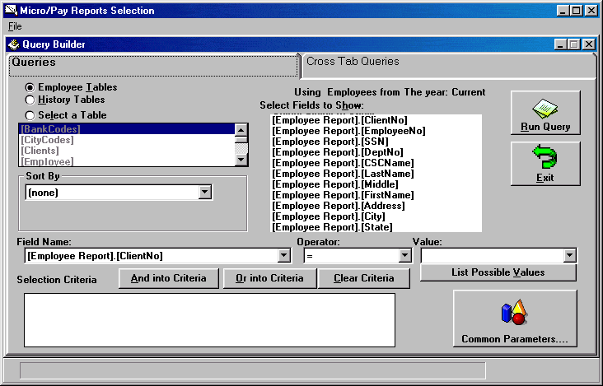
Figure 11

How to Build a Report
These are the steps needed to run a simple report on your payroll data:
1. Select a table
2. Select field(s) to display
3. Select Sort Order (optional)
4. Create Selection Criteria (optional)
5. Run Query

1. At the top left of the page select Employee Tables, History Tables, or any other individual table. The report generated will use the data from the selected table only.

2. Under “Select Fields to Show”, highlight the data fields you want displayed on your report by clicking on them. More than one field may be selected. Items may be deselected by clicking on them a second time.

3. The “Sort By” field will sort the information on the report by the field selected. The order will be in ascending order. Click the arrow to the right and a menu will appear displaying a list of fields to select from. Note: The sort field does not need to be displayed on the report.

4. The bottom portion of the screen allows the user to determine which records are to be included in the report. A button is provided which has a more user friendly interface for selecting some of the more commonly used selection criteria (such as hire date, department #, etc.).
All fields available for display and sort order are available as selection criteria as well. To use any of these items, select it from the “Field Name” drop down list. Then select the operator you wish to use for comparison and the value to compare against. The Operator defines the type of comparison to be made between the data provided by the data field and the value you specify.

Operators
= “equal to”
> “greater than”
>= “greater than or equal to”
< “less than”
<= “less than or equal to”
<> “not equal to”
Like

Special Operators: Like and “<>“
Like - the Like operator is used to compare strings such as names but not numeric values.
<> - Matches all values not equal to the value entered in the value field.

The Value is used in conjunction with the operator to make a comparison. The Value informs the query to include or exclude a set of values from the data provided by the selected data field. The “List Possible Values” button will generate a list of values considered appropriate for the data field selected. Click on the arrow button to the right to see the full list. When those fields are filled in, click on either the “AND into criteria” or the “OR into criteria” button. If you are using multiple criteria be certain to check that the ANDs and ORs are correct. For instance if you wish to select everyone in Departments 100 and 200 you must use the OR function since no employee can belong to 2 different home departments.

- Once the report has been built, click the “Run Query” button. This will bring up the Order Fields window (figure 12). Select the order you want the fields to be displayed on the report. Click “Done” when finished.

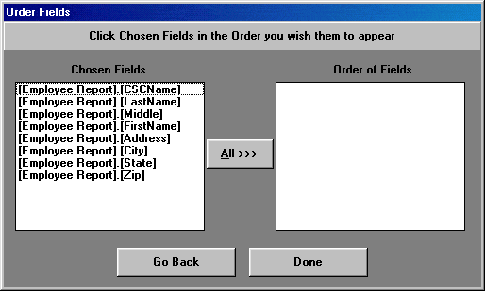
Figure 12

For example, to generate a report that will list employee name and pay rate (salary or hourly): Under Select Fields to Show, click on Employee.[CSCName], (this field displays the employee’s full name), Employee.[SalaryRate], and Employee.[HourlyRate]. Under Order By Field, click on the arrow to the right and select Employee.[LastName] from the drop down menu; this will sort the report based on the employee’s last name. Then the click “Run Query” button.

Select the order the fields are to be displayed on the report. Fields arranged from left to right with the topmost field being on the left side of the report. Double clicking on a field name in the left column will move it from to the next position available in the right column. You may click the “All” button at any time; all remaining field names will be moved over to the right column in their current order. Double clicking on a name in the right column will move that field name back to the left.

Then click the “Done” button. The next screen will display the data for the report. Click the “Print/Export” button to preview the printout (figure 13). The Previous and Next buttons allow you to move through the report page by page. Zoom changes the displayed report magnification, and Print sends this report to your printer. The Close button closes the report display but does not exit you from the Micropay Reports program.

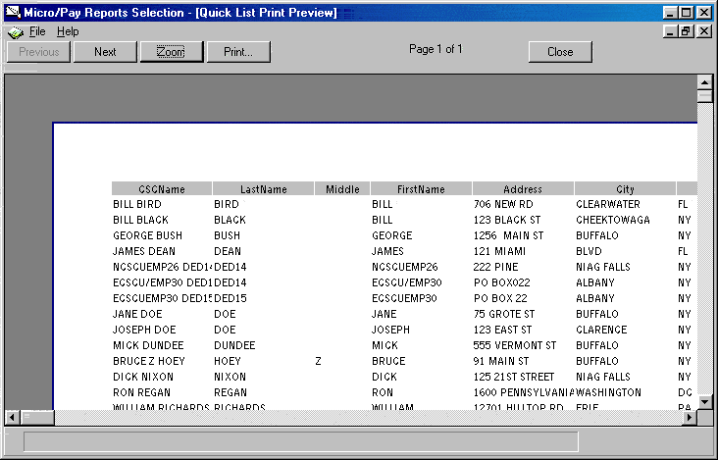
Figure 13

Special Cases

Current Terminated Employees
You can run reports on current terminated employees, i.e., in the year that they are terminated. Current terminated employees will appear in the employee list on the Employees tab and the reports will contain employee information (see the following section). See the following section on the available reports.

Dropped Terminated Employees
Terminated employees are dropped from the employee list at the beginning of a new year. You will still be able to retrieve information about these employees. To access information, you will need their employee number. Enter the employee number of the terminated employee on the Employees tab. Note the report will not contain the following employee information,

Employee Information

Employee Name
Social Security Number
Department Number
Birth Date
Date Hired
Date Terminated

The report will contain the employee number. The following is a list of reports you can run on terminated employees,

*Alpha Employee List
History Earnings by Employee
Deduction Report Summary
Unemployment Report

*Current terminated employees only.

Note: Sick-Vacation reports will still list current terminated employees’ name. No Sick-Vacation information will be listed on this report.

Index

Alpha Employee List, 4
Alpha Time Sheet, 4
And into Criteria, 19
Build a Report Using a Query, 17
And into Criteria, 19
Combination of “And into Criteria” and “Or into Criteria", 20
Operators, 19
Or into Criteria, 20
Special Operators: Like and “<>“, 19
Combination of “And into Criteria” and “Or into Criteria, 20
Deduction Report Summary, 4
Deductions, 9
Departments, 9
Employee Dates, 5, 9
Employee Hired/Terminated, 5
Employee Report, 5
Employee YTD Sick, 5
Employee YTD Vacation, 6
Employees, 9
Entering Dates, 9
Export Screen, 11
Exporting to a File, 12
Exporting to E-mail, 13
History Dates, 10
History Earnings By Employee, 6
How to Build a Report, 15
How to Run a Report, 2
Logging on to Micropay Reports, 2
Operators, 19
Or into Criteria, 20
Quarterly Department Report, 6
Rates By Department, 6
Report Parameters Screen, 8
Deductions, 9
Departments, 9
Employee Dates, 9
Employees, 9
Entering Dates, 9
History Dates, 10
Report Selected, 9
Report Selected, 9
Reports, 4
Alpha Employee List, 4
Alpha Time Sheet, 4
Deduction Report Summary, 4
Employee Dates, 5
Employee Hired/Terminated, 5
Employee Report, 5
Employee YTD Sick, 5
Employee YTD Vacation, 6
History Earnings By Employee, 6
Quarterly Department Report, 6
Rates By Department, 6
Sick-Vacation Report, 7
Unemployment Report, 7
Reports’ Toolbar, 11
Buttons, 11
Export Screen, 11
Exporting to a File, 12
Exporting to E-mail, 13
Sick-Vacation Report, 7
Special Cases, 22
Current Terminated Employees, 22
Dropped Terminated Employees, 22
Special Operators, 19
<>, 19
Like, 19
Unemployment Report, 7
Utilities Menu, 14
Check Employee/YTD Gross, 14
Quick Lists, 15

